Phonics, Early Reading and Writing at Holy Trinity

Phonics Information (reading and spelling)
At Holy Trinity C of E Primary School we believe that all our children can become fluent readers and writers. This is why we teach reading through Little Wandle Letters and Sounds Revised, which is a systematic and synthetic phonics programme. We start teaching phonics in Nursery and follow the Little Wandle Letters and Sounds Revised progression, which ensures children build on their growing knowledge of the alphabetic code, mastering phonics to read and spell as they move through school.

As a result, all our children are able to tackle any unfamiliar words as they read. At Holy Trinity C of E Primary School, we also model the application of the alphabetic code through phonics in shared reading and writing, both inside and outside of the phonics lesson and across the curriculum. We have a strong focus on language development for our children because we know that speaking and listening are crucial skills for reading and writing in all subjects.

More information regarding our teaching of phonics can be found here: https://www.littlewandlelettersandsounds.org.uk/resources/for-parents/, including Support for Phonics, How we teach videos and support for reading at home.

Phonics
The method by which we teach children to read by recognising the connections between the sounds of spoken words (phonemes) and the letters that are used to write them down (graphemes).
Phoneme
The smallest unit of sound that can be identified in words. We sometimes simply call this a ‘sound’, although it is helpful for children to use the term ‘phoneme’ from the beginning of our programme. (Note: We do not usually notice discrete sounds in words. We deliberately separate them out so that children can learn how our writing–reading system works. Children are first helped to identify the separate sounds in words through oral blending and segmenting, and this is reinforced as they begin to work through our systematic synthetic phonics programme.)
Grapheme
A letter or group of letters used to represent a particular phoneme when writing. With children, we sometimes call this ‘a sound written down’, although, as with ‘phoneme’, it is helpful for children to learn to use the correct term from the beginning. The way graphemes are used to represent phonemes in our written language is known as the ‘alphabetic code’.
Blend
To combine individual phonemes into a whole word, working all the way through from left to right. Once the GPCs involved have been learned, blending is the key process involved in reading words effectively. It is a skill that needs extensive practice. Practice in oral blending is very helpful, both before and during the process of learning to read. It is important to understand that blending sounds into a word is not simply a matter of saying them more quickly, nor of mixing them together like paint. Phonemes need to be joined into one continuous stream of sound to make a spoken word. Extensive practice, following teacher modelling, is the key.

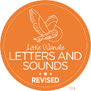
Blending
Blending is when sounds merge together so the full word can be heard.

As children move into Phase 2 they begin to recognise the letter sounds in a written word and blend them in order to produce the word. For example, c-u-p says cup, m-a-n says man. Children need this skill in order to read fluently.

As children move into Phase 3, they will be introduced to digraphs (2 letters making 1 sound) and trigraphs (3 letters making 1 sound). They need to identify digraphs such as sh, ch, ai and trigraphs such as igh, air, ear, in order to blend and build words accurately.

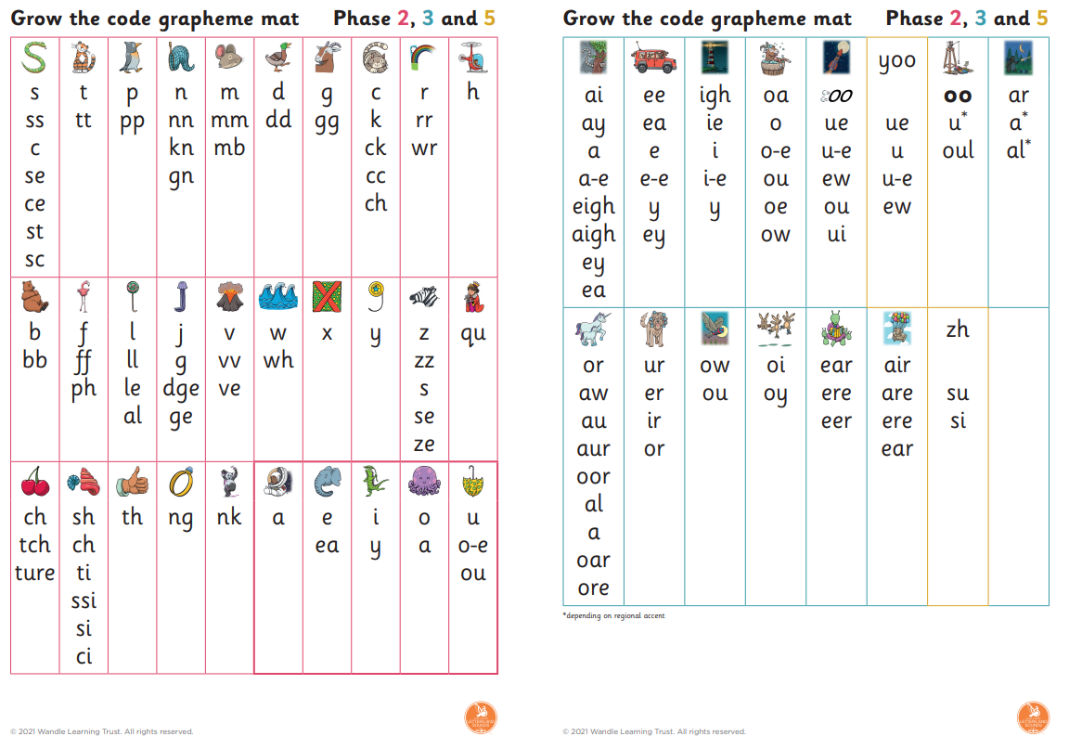

Early Reading Information
Your child will bring home two books.
- Decodable reading book: This book is for your child to read to you. It has been carefully chosen so that they can work out all the words.
- Sharing book: This book has words your child may not be able to read yet. It is for you to read to your child and talk about together.
How to read a story to your child
If you can find the time beforehand, read the read-aloud book to yourself first, so you can think about how you’re going to read it to your child.
On the first reading:
- Make reading aloud feel like a treat.
- Make it a special quiet time and cuddle up so you can both see the book.
- Show curiosity about what you’re going to read: ‘This book looks interesting. It’s about an angry child. I wonder how angry he gets…’
- Read through the whole story the first time without stopping too much. Let the story weave its own magic.
- Read with enjoyment. If you’re not enjoying it, your child won’t.
Read favourite stories over and over again.
On later readings:
- Let your child pause, think about and comment on the pictures.
- If you think your child did not understand something, try to explain: ‘Oh! I think what’s happening here is that…’
- Chat about the story and pictures: ‘I wonder why she did that?’; ‘Oh no, I hope she’s not going to…’; ‘I wouldn’t have done that, would you?’
- Link the stories to your own family experiences: ‘This reminds me of when …’
- Link stories to others that your child knows: ‘Ah! Do you remember the dragon in ….? Do you remember what happened to him?’
- Encourage your child to join in with the bits they know.
- Avoid asking questions to test what your child remembers.
- Avoid telling children that reading stories is good for them.
Why learning to read is so important
- Reading is essential for all subject areas and improves life chances.
- Positive attitudes to reading and choosing to read have academic, social and emotional benefits for children.
- Reading fully decodable books.
- Children must read books consistent with their phonic knowledge.
- It is essential not to use other strategies to work out words (including guessing words, deducing meaning from pictures, grammar, context clues or whole word recognition).
- Books must be fully decodable.
- Children need to read books in a progressive sequence until they can decode unfamiliar words confidently.
Parents’ and carers’ roles in home reading
- Parents/carers can have a huge positive impact on reading.
- Reading practice is essential to develop fluency.
- Children take home books they have read at school to re-read at home to build fluency – it is important your child re-reads their decodable book. This will improve your child’s accuracy and fluency when reading words.
- Reading to your child will encourage a love of books, along with developing vocabulary and discussion.
Writing Information
Segment
To identify each of the individual phonemes in a word, working all the way through from left to right. This is an important first stage of writing (spelling) a word but needs to be practised orally first. Counting the phonemes is often helpful in reinforcing this process (e.g. cat = c-a-t).
Writing
The earliest form of writing is ‘Mark Making’. As a child begins to make marks they need to develop their fine motor skills.
Developing Gross & Fine Motor Skills
- Big movements, jumpy movements, round & round, springing up and sliding down, movements with hands in the air (ensure your child knows direction up/down/across)
Fine Motor Control
- Involve the children in chopping and peeling in cooking activities
- Fasten buttons and zips
- Use finger rhymes, counting fingers, playing with words and sounds
- Provide small construction toys
- Develop pincer movement; show the children who to use tweezers to pick up small objects such as sequins
- Paints/finger paints
- Clay, playdough for modelling
- Encourage children to cut out large shapes or patterns
- Emphasise that circles or curly caterpillars need to be traced from the top and anti-clockwise
- Give the children thick paintbrushes and water to paint patterns on walls, fences etc.
- Let the children make patterns using pegboards
- Provide threading and weaving activities

Pencil Grip
Moving and Handling
- 8-20 months: Holds pen or crayon using a whole hand (palmar) grasp and makes random marks with different strokes
- 22-26 months: Beginning to use three fingers (tripod grip) to hold writing tools.
- 30-50 months: Holds pencil between thumb and two fingers, no longer using whole-hand grasp. Holds pencil near point between first two fingers and thumb.
- 40-60 months: Begins to use anticlockwise movement and retrace vertical lines. Begins to form recognisable letters. Uses a pencil and holds it effectively to form recognisable letters, most of which are correctly formed.

Making Marks
Up to 26 months
- Holds pencil/crayon in the palm of their hand like a palmar grasp
- Random marks, often made over other marks
- Is usually unable to distinguish between writing and picture
22-36 months/3 years
- Tripod grip
- Makes a definite attempt to make individual marks
- Attempts to close shapes – circles and lines
- Begins to use a dominant hand
- Combines shapes and lines to make one word
30-50 months/2.5 years -4 years 2 months
- May hold pencil between thumb and two fingers
- Copies adults and makes marks going across the page; these marks are often zigzags and wavy lines
- Has a clearer idea of the marks he/she wants to make
- May use either hand for writing
- Copies letters from their name
40-60 months/3 years 4 months – 5 years
- May hold pencil/crayon in a pincer grip between the thumb and index finger
- Makes individual marks and uses some letters from own name to communicate a message
- Begins to understand that drawing and writing are different
- Is becoming aware that print carries a message
- Forms symbols and some recognisable familiar letters that follow on next to each other left to right direction
- Writing conveys meaning and may ‘read’ own writing
- Writes a message using familiar letters
- Write some upper and lower case letters
- Writes name reliably

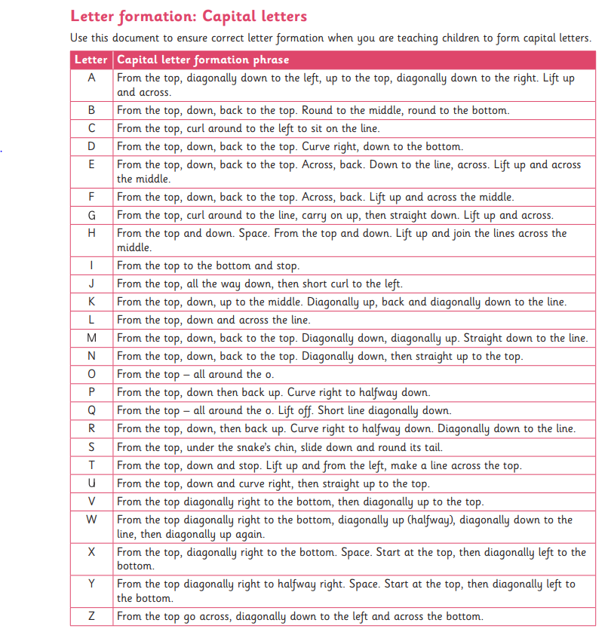
Written composition
Children’s writing generally develops at a slower pace than their reading. Before they can write independently in a way that can be read by others, they need to know:
- what they want to say
- how to identify sounds in words
- at least one way to spell each of the sounds of English
- how to form letters.

Handwriting
Reception: Cursive or pre-cursive script is not taught in Reception. Children are taught the correct start and exit points for each letter, which should not include ‘lead-in’ strokes from the line.
Year 1: Lead-ins to letters and joins between letters are introduced.
Year 2: By the end of the year children are expected to use lead-ins and use the diagonal and horizontal strokes needed to join some letters.
You can support your child’s early writing through encouraging them to use a variety of sizes and pens, pencils, crayons, felt tips and paint brushes to mark make, draw, colour, follow patterns or practise letter formation. To begin with some children may not have a ‘dominant hand’ so allow them to explore mark making with both. As they become more proficient they will have a preference for holding a pencil. When this happens we will encourage them, at school, to use an efficient drip so that the pencil control becomes more proficient as they begin to form letters accurately.

