Holy Trinity C of E Primary School
Reconnection, Recovery and Resilience

At Holy Trinity C of E Primary School, we ensure that the well-being of our children is at the centre of our thinking; we acknowledge that the children will have had different experiences during the past year. The common thread during the loss of time in school is the loss of routine, structure, friendship, opportunity and freedom. As a result of the change to normality, anxiety can be triggered. Knowing that an anxious child does not possess the capacity to learn fully and effectively, the school community has thought about the most effective way to support your child’s ability to learn. This approach will encompass and support the academic expectations for your child.
‘’The more healthy relationships a child has, the more likely he will be able to recover from trauma and thrive. Relationships are the agents of change and the most powerful therapy is human love.’’ (Bruce D. Perry)
‘Recovery Curriculum’
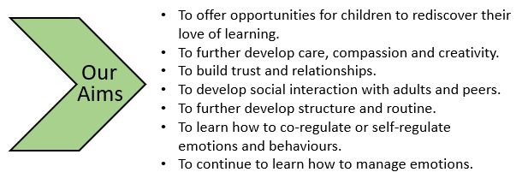
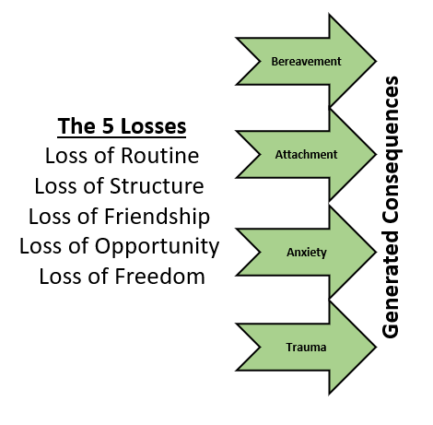
Our Recovery Curriculum at Holy Trinity C of E Primary School aims to enable our students to continue to develop their emotional resilience; developing their self-regulation and learning how to learn in a school environment once again whilst offering a full curriculum to enable children to flourish. Professor Barry Carpenter CBE, Professor of Mental Health in Education at Oxford Brookes University, has developed the Recovery Curriculum as a response to the losses described above. It is a way for schools to help children come back into school life, acknowledging the experiences the children have had. We want children to be happy, feel safe and able to be engaged in their learning. We have decided that a way to achieve this for the children is to acknowledge the importance of helping them lever back into school life using the following Five Levers.
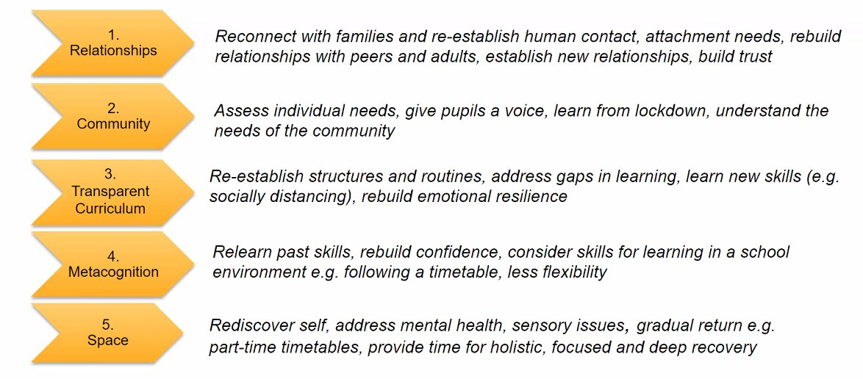

Reconnecting with Others
Support Intent | What this may look like
Supporting pupils to rebuild relationships and re learn how to interact and build relationships with others including sharing, turn taking, greeting and interact with others positively, play alongside and with peers, respond to my familiar and ne adults, seek adults to help, support and comfort me when I need them, know which adults help me and can support me to keep safe when I need them. | There will be opportunities within the day where the focus is on rebuilding relationships with peers and adults. This may be in the form of:  - Independent learning to nurture parallel and joint play.  - Turn taking games and activities.  - Sharing games and activities.  - Intensive interaction opportunities using call and response  - Time where adults can give sole attention to pupils re-building relationships  - Games and activities where pupils can work together such as board games or outdoor PE games.  - Safety work about who keeps us safe and who can keep us safe at school and at home and in the community.  - Safety work about how adults can help us.  - Activities that link to children’s interests to show we are interested in them.

Supporting Pupils to Manage Feelings and Behaviours
Support Intent | What this may look like
Supporting pupils to understand their emotions and feelings and begin to process the experiences they have had. Supporting pupils to relearn some positive behaviour which they may have forgotten being outside of the school environment. Supporting pupils to engage with self-regulation strategies and tools which help me to feel safe and calm. Supporting pupils to understand the world we live in with tools and strategies to help them process what is different and what we can do to help. | There will be clear routines which are supported by clear communication which may include use of visual timetables so pupils know what is happening each day and at each part of the day. Some structures and boundaries may be different in school because of social distancing and processes related to this so we may use are social stories and use of visuals to guide and support.  The structure will be supportive and provide opportunities within this that enables and allows pupils to express themselves and express the experiences they have had whilst they were not at school. We will do this by being clear with boundaries and using therapeutic approaches to supporting behaviour and emotions. We will also be using therapeutic tools to support pupils in communicating with us such as building in regular discussion time, play times, tools such as Thrive.  There will be regular sessions where we explore and express emotions and will support pupils to explore their feelings as well as modelling processing and talking about feelings and emotions linked to this experience.  There will be regular opportunities for pupils to engage in self – regulation activities such as with sensory breaks, active breaks, and use of resources which support individuals. In addition, there will be lots of opportunities for pupils to practise their communication so that they are able to feel like they have a voice and are able to express their wants and needs.

Supporting Enjoyment and Achievement
Support Intent | What this may look like
Supporting pupils to have moments here they feel success and can engage in moments of enjoyment and achievement which may feel usual to being in school. This will be within pupil’s abilities and easily accessible recognising that when pupils have experienced trauma, their abilities to learn new concepts and be challenged is less. Pupils often use schemas of learning which they are familiar to explore when processing events in their lives and planned provision will focus on what is familiar. | We will use familiar curriculum type sessions, offering a full curriculum, that pupils will be used to and that provide children with experiences that feel like normal. Using what we know about learning and how children process, this will look like familiar structured sessions in pupil’s day and opportunities to engage in play opportunities. Sessions which will feel familiar will be different for each learning hub and class group dependent on age/phase development.  Learning in these sessions will link to previous and current topic learning or children’s key interests and motivators. Children will have missed out on many opportunities being at home that they are naturally exposed to at school like peer play, active opportunities and experiences which develop their cognition and learning and these will be built into each day to support children to have a broad range of opportunity, experience and fun.

Supporting Physical Health and Wellbeing
Support Intent | What this may look like
Supporting pupils to re-engage with physical health and well-being routines as well as learn new routines which will support pupils to keep safe and enable infection control. This will include hand washing, social distancing, understanding of new school routines as well as supporting pupils with their personal care and tolerating differences in these routines such as use of an alternative hygiene room facility or being supported in a different way for eating/ drinking. Supporting pupils to be independent and physically well through active sessions, use of outdoor space and understanding about keeping physically well. | We will be planning in lots of time where children are able to explore and re-investigate their environments to become familiar with what might be different (i.e. one-way systems in school, different markings in school, different access to resources in the classroom, some rooms which are closed) and understanding these differences will be supported with social stories, photos and pictures.  Learning in supporting my physical health and well-being will focus on managing and coping within new processes keeping safe. This will include:  - Understanding what is different about school and how to navigate this environment.  - Hand washing and hygiene measures.  - Adapting to using areas of the school that may not be usual and being in environment and with staff that are not usual.  - Keeping and maintaining social distancing.  - Catch it, kill it, bin it messages.  - Health and hygiene sessions focusing on washing, being independent and looking after yourself.

Remote Learning Programmes
This remote learning policy has been written as guidance for staff and parents during the time that schools are closed due to COVID-19. It sets out the systems and technology that staff will use to keep the learning experience going for children, and details how they can be used effectively and safely, while allowing for the differing needs of families.
The school’s usual Online Safety Policy and Acceptable Use Agreements still apply at this time but this policy is an addendum in these unprecedented circumstances.
A flexible approach:
We understand that everyone’s circumstances at home will be different. Some families have one child to support while others have several. Some families have one device to share while others may have more – and some things may work differently on different devices. Some parents will have plenty of time to help their children learn, while others will be working from home and may have much less time and some children will be able to work more independently than others or need greater challenge.
Due to this we are providing a flexible approach to remote learning. The government’s emergency legislation lifts curriculum requirements for schools, giving flexibility to provide support, activities and education in the way they see fit. We won’t be providing a full school day of activities as this will be unmanageable for the majority of families – not to mention keeping children at a screen for far too long.
We hope to offer a variety of daily online and offline learning activities across the curriculum so that pupils can dip in and out and work their way through things as and when they are able.
Sites and services:
We are currently delivering remote learning through a range of sites and services, most of which are part of our usual online provision for children: Twitter is our main method of communication between school and families.
 | An adaptive literacy intervention that develops the fluency, comprehension and motivation in order to develop successful readers.  Individual log ins | www.student.readingplus.com
 | Differentiated maths activities can be assigned and completed through Mathletics (Whole School) | www.mathletics.com
 | Spelling Shed is a unique application that is suitable for ages 5 to 11 and focuses on spelling and literacy. Differentiated spelling activities are set and can be practised at home on any SMART device. This app has been developed to be ‘dyslexia friendly’ using the ‘Open Dyslexic’ font.  Reception – Y6 | www.play.edshed.com
 | Differentiated number activities are set and can be practised at home on any SMART device. Reception – Y6 | www.play.edshed.com
 | Access to a range of reading books, across a selection of genres, closely linked to reading age and phonic gaps. Teachers monitor reports and set new books when required. | www.activelearnprimary.co.uk
 | Lexia® Core5® Reading supports educators in providing differentiated literacy instruction for students of all abilities in grades pre-K–5. Lexia’s research-proven program provides explicit, systematic, personalised learning in the six areas of reading instruction, targeting skill gaps as they emerge, and providing teachers with the data and student-specific resources they need for individual or small-group instruction. | https://www.lexiacore5.com/register
 | Symphony Maths is a program which helps students connect the big ideas in mathematics. Big ideas are building blocks for mathematicians. As they learn new concepts, students build on previous foundational concepts to help them understand and master new material.  (individual logins) | https://content.symphonylearning.com /assets/student/start.html?v=7.2
 | The SpuQ Times Tables game lets you practice the times tables 1 to 12 one by one. Choose the multiplication table you want to learn and start solving the math problems right away. There are two levels; easy and difficult. At the easy level, the exercises will appear in order. At the difficult level, the exercises are random. | https://www.timestables.co.uk/spuq-times-tables.html

