**Holy Trinity C of E (Aided) Primary**

**Love Your Neighbour**

**As Yourself**



**Seaton Carew**

Crawford Street

Seaton Carew

Hartlepool

TS25 1BZ

Phone: 01429 855620

01429 864376

[**www.holytrinitycofeseatoncarew.co.uk**](http://www.holytrinitycofeseatoncarew.co.uk)

**e-mail:** [**admin@hpoolholytrinity.org.uk**](mailto:admin@hpoolholytrinity.org.uk)

**@htseaton (twitter)**

29th April 2022

Dear Parents and Carers

I am writing to tell you some very exciting news about a new member of our school community who will be joining us, for training, in the near future with a view to them becoming part of our Emotional, Social, Mental Health and Well Being offer in school.

You may be aware that there is a growing movement to introduce the concept of ‘Well-Being dogs’ into schools. Well-being dogs are being used as a source of comfort and relaxation for children and adults who may need ‘someone to talk to’ or just someone who will accept them and offer comfort or a calming influence in their lives. There is much evidence that the children who struggle with relationships or managing their own emotions gain a great deal from spending time with a pet. Children can benefit educationally and emotionally, increase their understanding of responsibility and develop empathy and nurturing skills through contact with a dog.

We know that this pandemic has had a significant impact on many of our pupils emotionally and socially. Therefore, we are delighted that the Academy Council and Learning Trust have agreed for us to be able to introduce a Well-Being dog into our school.

Staff carried out research to find an appropriate breed of puppy, which is known to be intelligent and receptive to training, will have the right temperament and is suitable for interaction with children.

On March 25th we collected a spaniel puppy who will be trained to be a Well-Being dog for our school.

We have discussed the practicalities, both for the animal’s sake and for the sake of the children and adults within school including risk assessments, training, dog toileting and allergies. We will be working closely with K9 Pursuits from Newton Aycliffe to ensure the dog is appropriately trained.

Our aim is that all children across school who wish to have contact with the dog will have the opportunity to have quality time with him. From the start we would like for the children and the whole school community to be involved.

To reassure you, our dog will not be off his lead in school and will be trained to a high level. We are very mindful that introducing a dog into the school setting should not be a distraction to the children’s learning but to enhance our school ethos and the experiences we offer.

In the Summer term our dog will be in school for training, getting used to the school environment, the noises sights and sounds. Therefore, whilst present in school he will not be interacting with children or staff until he is fully trained, although he will be visible in school from a distance.

During the Autumn Term, once we are certain that the dog is fully training trained, he will be introduced into classrooms, groups rooms and Worships. Eventually we aim for the dog to work with classes, groups and individuals with closer contact (whilst remaining supervised). We will gain permission from parents and carers at this point to ascertain if children wish to interact and if they have any allergies or fears which we need to plan for.

We will also be training all staff and children on how the Well Being Dog, Stanley, will work in school and how they will be able to choose to interact with him in the future starting with an assembly to discuss the role he will play within our school.

We have attached some further information including a policy, a risk assessment and some questions and answers.

Stanley will be in school, for training, under close supervision, in the near future.

If you have any questions or queries regarding the introduction of a Well Being Dog into our learning environment, please do not hesitate to ask.

Below are some pictures of our dog, his name is Stanley.

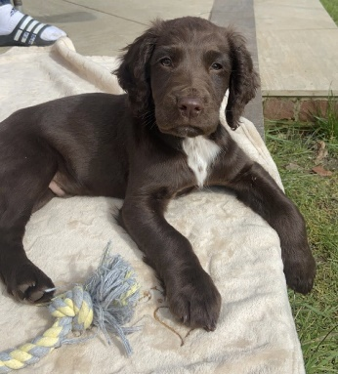





Yours sincerely

Mr M Johnson

Chair of Academy

