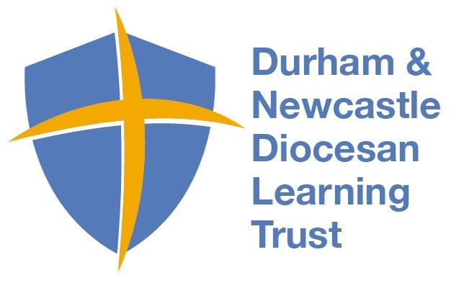
Physical Education Medium Term Plan- Spring 2
This term students will learn and understand the rules of Tennis/Send and Return, practice the requisite skills, and demonstrate their abilities to perform various physical movements in a competitive game.
Year Group: 1 Topic- Tennis/Send and Return
National Curricular Focus
- Extend co-ordination for hitting and striking
- Participate in simple sending and receiving games
- Score points through sending balls using hitting skills to correct areas.
Lesson Objectives for weeks1-6
- I can slide beanbags/balls to a partner
- I can balance a beanbag on my racket
- I can balance a ball on my racket most of the time
- I can travel with an item (ball/beanbag) on my racket
- I can attempt to hit a ball
- I can push a ball along the follow towards a target (pin/can).
- I can practice sending a ball in a range of ways to a partner
- I can move in position to get in line with a ball
- I know the basic rules of tennis (balls to bounce once only)
- I can describe how to work with a partner to receive and return successfully.
- I can hold a racket using the handshake grip

Assessment covered in term
Assessment statements from Progress in PE

4. Games – Attacking and Defending, Striking and Fielding (Tennis, Football, Cricket, Rounders)

- I can hold a racket using the handshake grasp
- I can balance a ball on a flat racket whilst stationary
9. I can volley a ball/balloon on a racket

Vocabulary
Hit  Send  Collect  Stop  Net  Throw  Roll  Strike | Feed  Pick up  Strike  Court  Lines  Spots  Balls  Catch  Bowl

