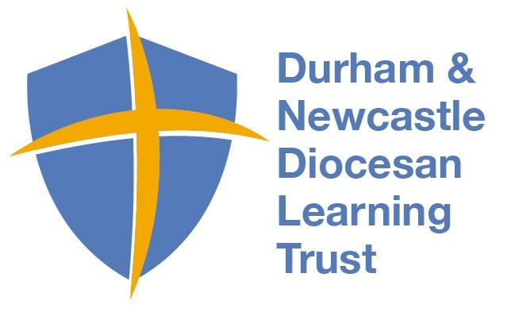
Physical Education Medium Term Plan- Spring 2
This term students will learn and understand the rules of Tennis, practice the requisite skills, and demonstrate their abilities to perform various physical movements in a competitive game.
Year Group: 3 Topic- Tennis
National Curricular Focus
- Play in competitive games developing simple tactics
- Master basic movements including hitting, returning, moving to return
- Work collaboratively to use basic tactics
Lesson Objectives for weeks1-6
- I understand how to hold a tennis racket using the ‘Shake the hand grip’
- I can control a tennis ball moving around my racket
- Pupils to be able to serve using the ‘pop, drop, strike’ technique
- to be able to strike a ball using a forehand and backhand technique
- I can stand in a ready position
- Pupils to be able to return a ball
- Play in a game against an opponent
- I can hit a target
- Pupils to be able to throw a ball to a partner high/low
- I can move towards a ball to attempt to return the ball
- I can take part in a rally with someone else
- I can score a tennis game and know the difference between in and out in a game situation
Assessment covered in term
Assessment statements from Progress in PE

4. Games – Attacking and Defending, Striking and Fielding (Tennis, Football, Cricket, Rounders)
- I can roll a ball around my racket while on the move in a set area
- I can volley a ball on a racket while moving around and avoiding others
- I can sustain a rally for more than 10 strikes over a net

6. Achieving my Personal Best and Healthy, Active Lifestyles
- I can identify an area of PE that I need to improve in
- I can show that I have improved in this area (timed event/jump distance/throw length)

Vocabulary
Hit  Return  Court  Forehand  Backhand  Boundary  Points | Score  Net  Racket  Strings  Frame  Tactics  Underarm  Overarm

