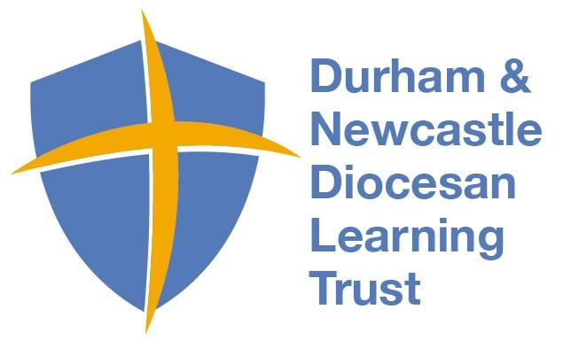
Physical Education Medium Term Plan- Spring 2
This term students will learn and understand the rules of Netball, practice the requisite skills, and demonstrate their abilities to perform various physical movements in a competitive game.
Year Group: 6 Topic- Netball
National Curricular Focus
- Play in competitive games developing fluency in skills and techniques
- Work in collaboration to play in different formations
- Compare team performance again other teams
Lesson Objectives for weeks1-6
- I can defend and attack in a game
- I can attempt not to break the double bounce rule
- I can use throwing and catching skills to score as part of a team in a game
- I can maintain the correct distance when marking the ball
- I can use marking as a defencing tactic in a game situation
- I can use a range of passing techniques
- I know how to shoot in netball
- I can describe what a rebound is as an attacker and a defender
- I can attempt to knock a ball away from my opponent if I cannot catch
- I can recognise when to catch and when not to catch
- I can work in a team

Assessment covered in term
Assessment statements from Progress in PE
Year 6- Throwing and Catching (Team Games, Netball, Rugby, Basketball)
- I can demonstrate a full range of passing techniques (chest, shoulder, bounce, overhead with large ball, underarm and overarm with small ball)
5. I can receive a ball, pivot and offload (pass on) with fluency
6. I can run towards a ball, catch it and turn in the air to face the other way
7. I can offload the ball at the right time to avoid losing possession
10. I can throw and catch a ball quickly and accurately every time, even under pressure

Year 6- Achieving my Personal Best and Healthy, Active Lifestyles

- I can set myself a target in PE (throw further, run faster, jump higher)

Vocabulary

