

Holy Trinity C of E Primary

Love Your Neighbour
As Yourself
NEWSLETTER – 14th October 2022
www.holytrinitycofeseatoncarew.co.uk

E-mail: admin@hpoolholytrinity.org.uk
@htseaton (twitter)

Dates for your Diary
21st October School Closes for Half Term
31st October School Opens
2nd Nov Church
9th Nov Church Remembrance Service
16th Nov Church
23rd Nov Church
30th Nov Church
7th Dec Church
12th Dec Church 1.15pm Nativity Service (half of Rec/Y2/Y4/Y6)
13th Dec Church 1.15pm Nativity Service (half of Rec/Y1/Y3/Y5)
(Reception groups will be emailed later)
20th December School Closes for Christmas
4th January School Opens

Tempest Photography – Wed, 19th October
Tempest photography will be in school on Wednesday, 19th October, to take individual and sibling photographs.

Christmas Cards
Reminder that the deadline to approve and order items online is 19th October 2022. Any problems please email support@classfundraising.co.uk

Curriculum Meetings
Thank you to all parents and carers who attended our class welcome and curriculum meetings at the beginning of term. These meetings were held for you to meet your child's teacher and teaching assistant and to have an overview of the curriculum this year. Staff will have outlined any formal statutory assessments that your child will be taking this year eg phonics, SATs, timetables and will have also discussed reading and other homework. We had over 48% of parents attend these meetings. The power point presentations and information from these meeting can be viewed on the school website so if you couldn't attend the meeting you can still access the information online. The Nursery Presentation will go onto the website and Seasaw on Monday.

School Meals
Any changes to lunch arrangements should be emailed to admin2@hpoolholytriniy.org.uk, before the start of the next half term holidays, Friday 21st October 2022. School meals are £2.23 a day and are payable through ParentPay. If payment is not received within the week then you may be asked to provide your child with a packed lunch.

Parental Consultations
Week commencing 7th November, you will be invited, via School Cloud, to an individual, face to face meeting, in school to discuss your child's attainment and progress so far, this academic year alongside any concerns that you may have. If your child has a Special Educational Need or Disability and is on our SEND Register, you will be offered an additional meeting time to discuss your child's Individual Education Plan. We ask that you do not bring your child to this meeting. Our Seaton Carew Childcare facility will be open during the meeting times so children can be booked in, via parent pay. Please monitor your email after half term for this invitation and book your appointment through the School Cloud online booking system.

Children in Need
This year Children in Need will take place on Friday 18th November. School Council have come up with an idea of doing a DIY SPOTacular T-Shirt Competition. Children who wish to participate are asked to make their own spotty t-shirts at home and wear them to school on Friday 18th November. To enter the competition, we kindly as for a minimum donation of £1 to Children in Need payable via ParentPay. There will be a prize and certificate for the winner of the SPOTacular T-shirt Competition. The school council will also be hosting a Pudsey Treasure Hunt which will involve the children following clues around the school to find prizes and the missing Pudsey Bear, once the missing Pudsey Bear has been found each child will win a prize.

Cross Country Final
A huge well done to Grace Kane who represented our school on Wednesday in the Tees Valley county finals held at Stewarts Park Middlesbrough.

Y6 Hartlepool College of Education Visit
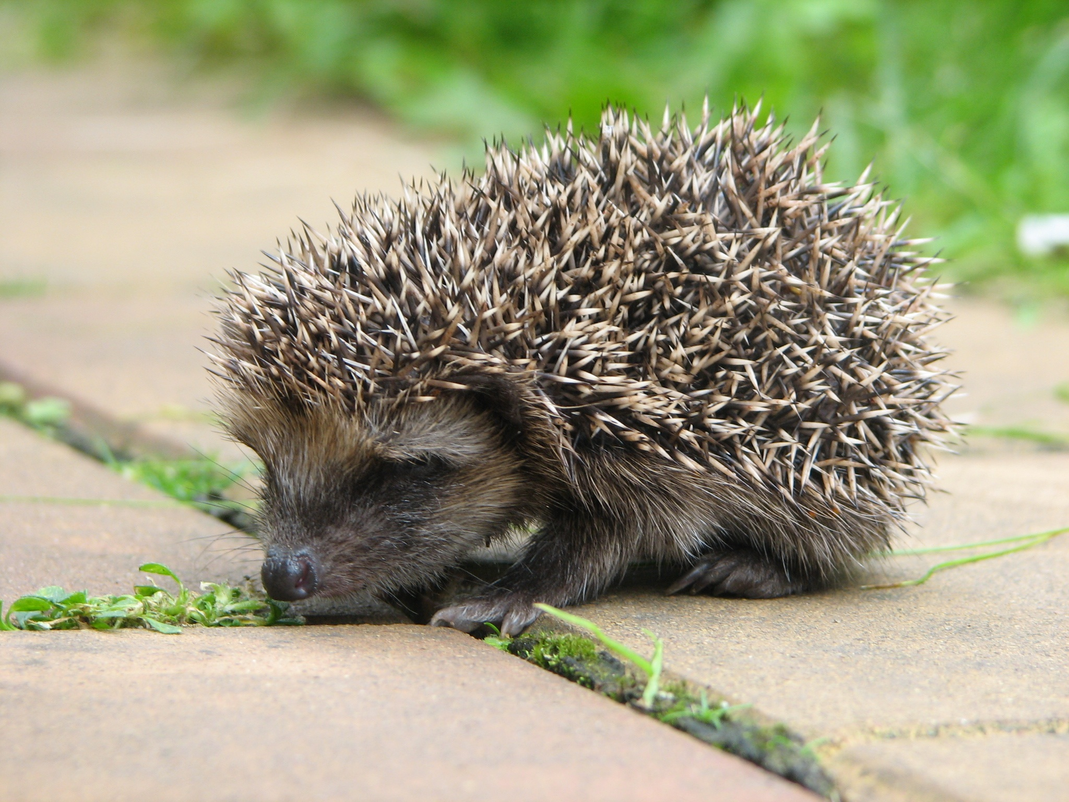
Today our Year 6 pupils visited Hartlepool College of Further Education. The visit included designing and building individual insect hotels which the pupils thoroughly enjoyed. In addition, we were gifted a hedgehog home for our frequent friendly visitor. The children were also given time to look around and explore the Aviation Travel and Tourism Department. Check out the photos on our Year 6 Twitter account.

