
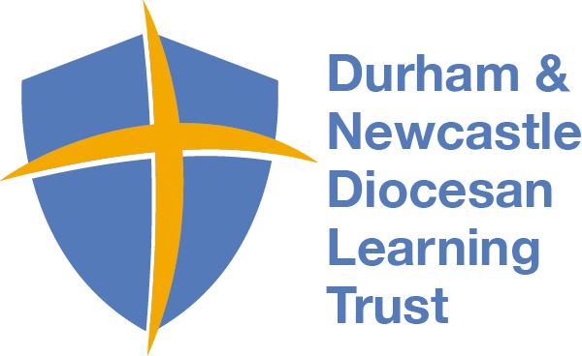
Holy Trinity C of E Primary

Love Your Neighbour
As Yourself
NEWSLETTER – 2nd December 2022
www.holytrinitycofeseatoncarew.co.uk
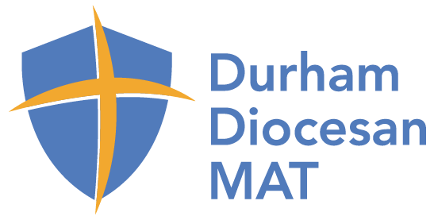
E-mail: @htseaton (twitter)

Dates for your Diary
9th Dec Christmas Dinner
12th Dec Church 1.15pm Nativity Service (half of Rec/Y2/Y4/Y6)
13th Dec Church 1.15pm Nativity Service (half of Rec/Y1/Y3/Y5)
(Reception groups will be emailed later)
20th December School Closes for Christmas
4th January School Opens

Information from the PTA
Today’s Non-Uniform Day was a huge success. Thank you to everybody who sent in the suggested class donations for the PTA Christmas raffle. It looks like there will be some fantastic prizes and hampers being put together from your donations. Raffle tickets will be sent home next week with your child.

Christmas Clothing
On Friday 9th December pupils can come to school wearing Christmas clothing (non-uniform). This year we are again collecting for the Hartlepool Food Bank. Please send any donations such as cereal, soup, pasta, rice, tinned tomatoes, pasta sauce, lentils, beans and pulses, tinned meat, tinned vegetables, tea or coffee, tinned fruit, biscuits, UHT milk, fruit juice etc. into school on the morning of Friday, 9th December only. No fresh produce should be donated. Thank you.

Late Arriving Pupils
There seems to be a number of pupils who are still arriving late to school on a morning. Since September there has been 106 occurrences of pupils arriving after 8:30am and who have signed in late on the office system.
The Attendance Officer undertakes a monthly register check, including lateness, which can result in monitoring and a letter being sent out. Please can we remind parents/carers that the school gates open at 8:20am for a prompt start of 8:30am.

Dodgeball
Today some of our Y6 girls and boys competed in the school collective cluster held at Brierton sports centre. The mixed team of girls and boys played 7 rounds and successfully made it through to the town final on Wednesday, 7th December. Well done to everyone who took part and good luck in the final.

