Holy Trinity C of E Primary School
School Improvement 2022-23
Subject | Computing
Staff | Kate Ridley
Strategic Subject Intent |  |  | Intended Impact
We recognise that our children are citizens of the digital age, and we intend to provide them with the skills and concepts needed to thrive in a future that is increasingly dependent on computational thinking and creativity. Our high-quality computing education equips pupils to use computational thinking and creativity to understand and change the world.  Our curriculum enables children to use the internet in a safe and respectful way, as well as understanding how and where to seek help and support.  To write and debug code successfully and with confidence; analysing problems in computational terms.  To competently and creatively use information communication technology and recognise the use of technology in the wider world. |  |  | - Curriculum is sequenced carefully considering a progression in knowledge and skills.  - Code language chosen accounts for potential semantic and conceptual difficulties.  - Children recognise use of technology beyond school and how technology has changed our lives.  - Teaching approach is considered to help children to remember more (including consideration of discrete and cross-curricular opportunities)  - Curriculum lead links with local CAS communities and DLT Hartlepool for CPD opportunities.
Subject Implementation |  |  |  | RAG |  |  |  | Comments
 |  |  |  | Autumn | Spring |  | Summer
Computer Science: Ensure declarative knowledge (‘knowing that’) and procedural knowledge (‘knowing how’) are identified, sequenced and connected in the curriculum. Skilful use of technology is underpinned by procedural and declarative knowledge. |  |  |  | Maternity leave
Computer Science: Review the programming curriculum to ensure block-based languages (which overcome difficulties with syntax) do not cause semantic and conceptual difficulties. |  |  |  |  |  |  |  | Share with staff.
Computer Science: Introduce teaching using micro:bit devices. |  |  |  |  |  |  |  | Bid for new micro:bit devices successful.
Information Technology: Develop curriculum to include use of technology (beyond school) and how technology has changed lives e.g. the early use of computers such as Colossus, which contributed to saving lives in the Second World War and technologies that have transformed our lives, such as the internet and the range of services that use it. Knowledge of computing contexts also includes emerging technologies and associated fields, such as data science and artificial intelligence, which are set to shape our future.
Information Technology: Ensure curriculum has opportunities to teach pupils about the use of digital mapping and how they can drop a pin anywhere on a map to visit that location virtually. Pupils develop knowledge of how this computing context is useful, such as being able to view a location before visiting it. |  |  |  |  |  |  |  | Some evidence of this has been used during English lessons to show children more of a book setting etc.  e.g. Katie in London, Holes
Support teachers to use a semantic wave approach to enable children to remember more in their learning. Introduce abstract concept, move to concrete activity and relate back to abstract concept.
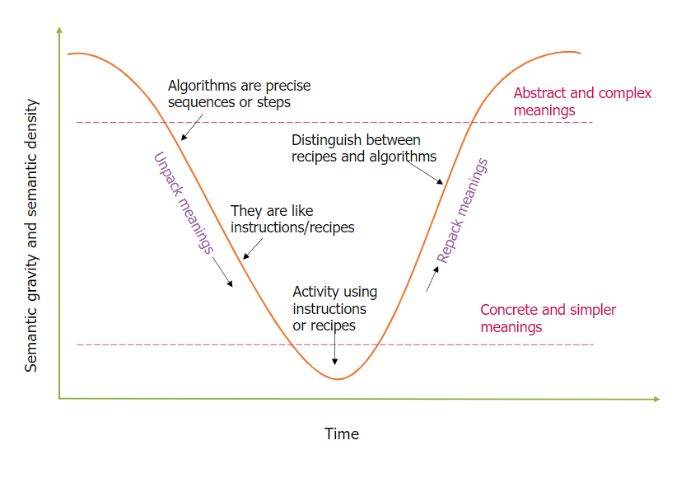
ICT skills involve use of Microsoft Office |  |  |  |  |  |  |  | Have looked to move across to Kapow if necessary in Autumn term
Ensure decisions to teach the subject in a discrete or cross-curricular way are based on how best to teach the intended curriculum.
Fluck and others also note how cross-curricular integration of similar subjects, such as ICT, was ineffective and put these subjects in a vague place in the curriculum. Our own research in 2011 highlighted weaknesses in taking a cross-curricular approach to teaching ICT.
Leaders and teachers use the expertise of subject communities to develop teachers’ subject knowledge.
To support new staff with Computing curriculum. |  |  |  |  |  |  |  | Need staff meeting time
Funding & Resources |  | Cost (Time & Money) |  |  |  | Links to Academy Council
 |  | Time to review curriculum |  |  |  | -
Evaluation

