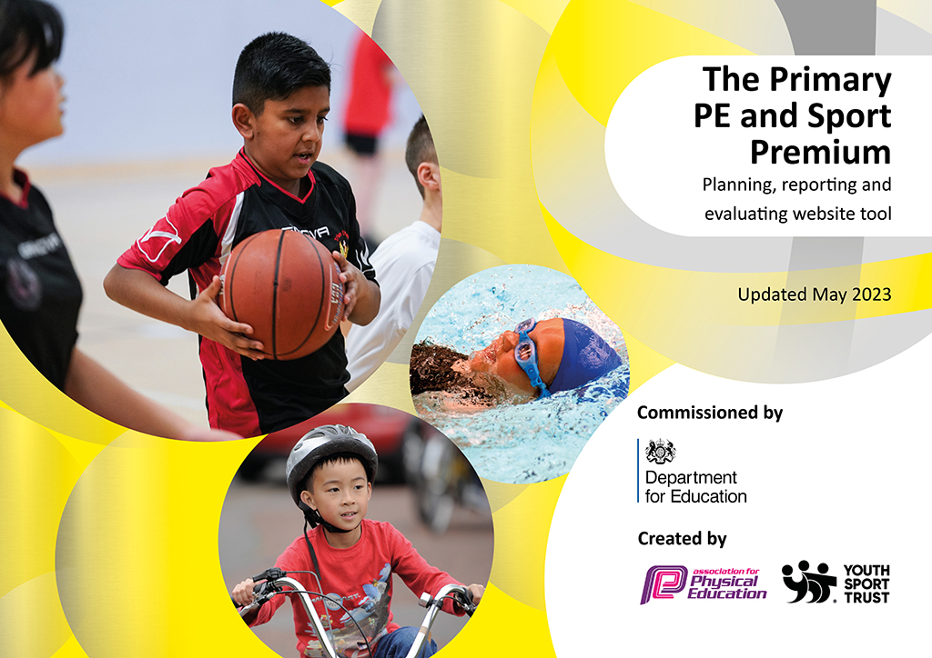
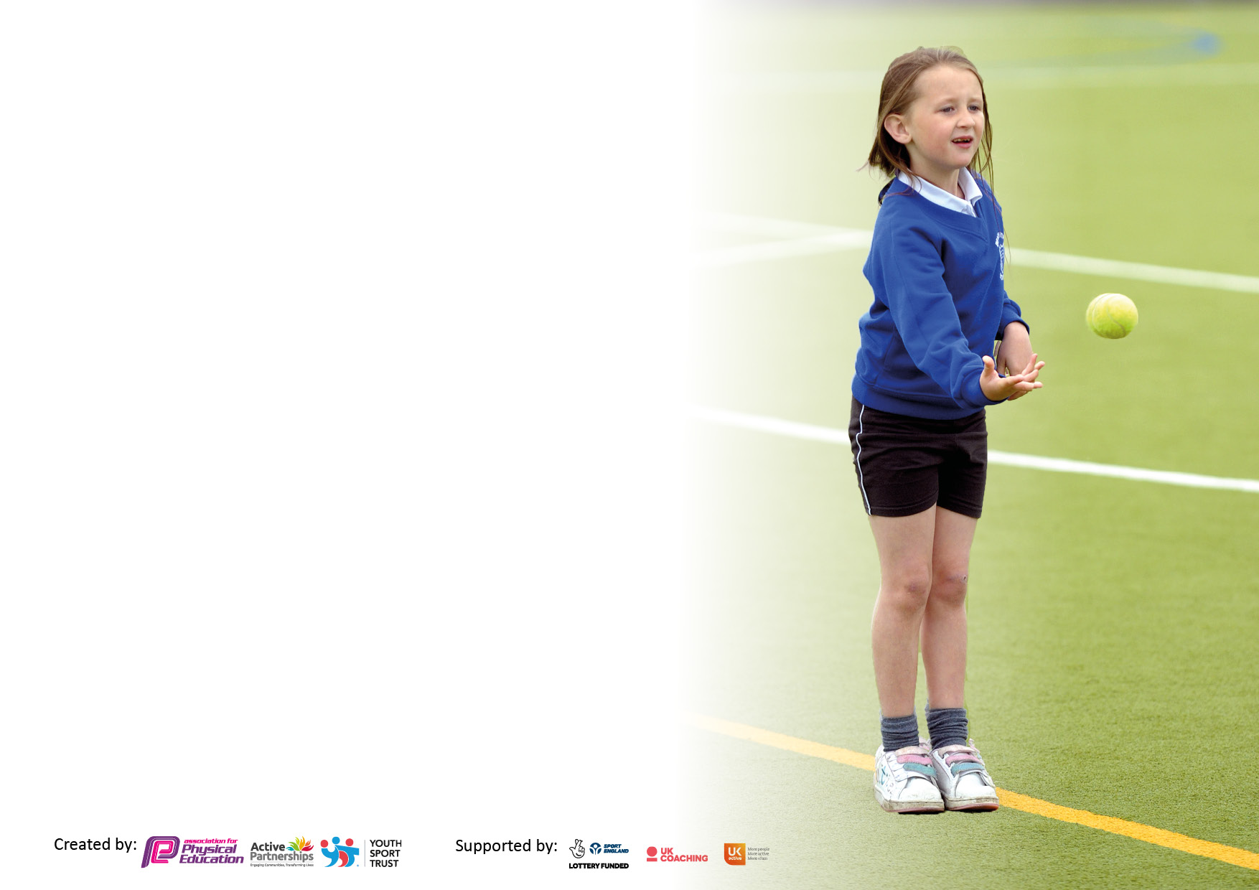

It is important that your grant is used effectively and based on school need. The Education Inspection Framework makes clear there will be a focus on ‘whether leaders and those responsible for governors all understand their respective roles and perform these in a way that enhances the effectiveness of the school’.

Under the Quality of Education Ofsted inspectors consider:
Intent - Curriculum design, coverage and appropriateness
Implementation - Curriculum delivery, Teaching (pedagogy) and Assessment
Impact - Attainment and progress

To assist schools with common transferable language this template has been developed to utilise the same three headings which should make your plans easily transferable between working documents.

Schools must use the funding to make additional and sustainable improvements to the quality of Physical Education, School Sport and Physical Activity (PESSPA) they offer. This means that you should use the Primary PE and sport premium to:

- Develop or add to the PESSPA activities that your school already offer
- Build capacity and capability within the school to ensure that improvements made now will benefit pupils joining the school in future years
- The Primary PE and sport premium should not be used to fund capital spend projects; the school’s budget should fund these.

Please visit gov.uk for the revised DfE guidance including the5keyindicatorsacrosswhichschoolsshoulddemonstrate an improvement. This document will helpyoutoreviewyourprovisionandtoreportyourspend.DfEencouragesschools to use this template as an effective way of meeting the reporting requirements of the Primary PE and Sport Premium.

We recommend you start by reflecting on the impact of current provision and reviewing the previous spend.

Schools are required to publish details of how they spend this funding, including any under-spend from 2021/2022, as well as on the impact it has on pupils’ PE and sport participation and attainment. The funding should be spent by 31st July but the DfE has stated that there will be no clawback of any unspent money so this can be carried forward into 2023/24.

We recommend regularly updating the table and publishing it on your website throughout the year. This evidences your ongoing self-evaluation of how you are using the funding to secure maximum, sustainable impact. Final copy must be posted on your website by the end of the academic year and no later than the 31st July 2023. To see an example of how to complete the table please click HERE.

Details with regard to funding
Please complete the table below.

Total amount carried over from 2021/22 | £0
Total amount allocated for 2021/22 | £17,780
How much (if any) do you intend to carry over from this total fund into 2022/23? | £0
Total amount allocated for 2022/23 | £17,790
Total amount of funding for 2022/23. Ideally should be spent and reported on by 31st July 2023. | £17,790
Swimming Data
Please report on your Swimming Data below.

Meeting national curriculum requirements for swimming and water safety.

N.B. Complete this section to your best ability. For example you might have practised safe self-rescue techniques on dry land which you can then transfer to the pool when school swimming restarts.
Due to exceptional circumstances priority should be given to ensuring that pupils can perform safe self rescue even if they do not fully meet the first two requirements of the NC programme of study
What percentage of your current Year 6 cohort swim competently, confidently and proficiently over a distance of at least 25 metres?  N.B. Even though your pupils may swim in another year please report on their attainment on leaving primary school at the end of the summer term 2023.  Please see note above | 100%
What percentage of your current Year 6 cohort use a range of strokes effectively [for example, front crawl, backstroke and breaststroke]?  Please see note above | 100%
What percentage of your current Year 6 cohort perform safe self-rescue in different water-based situations? | 100%
Schools can choose to use the Primary PE and sport premium to provide additional provision for swimming but this must be for activity over and above the national curriculum requirements. Have you used it in this way? | Yes/No

Action Plan and Budget Tracking
Capture your intended annual spend against the 5 key indicators. Clarify the success criteria and evidence of impact that you intend to measure to evaluate for pupils today and for the future.

Academic Year: 2022/2023 | Total fund allocated: 17,790 | Date Updated: 14.7.23
Key indicator 1: The engagement of all pupils in regular physical activity – Chief Medical Officers guidelines recommend that primary school pupils undertake at least 30 minutes of physical activity a day in school |  |  |  | Percentage of total allocation:
 |  |  |  | 12.36%
Intent | Implementation |  | Impact
Your school focus should be clear what you want the pupils to know and be able to do and about  what they need to learn and to  consolidate through practice: | Make sure your actions to achieve are linked to your intentions: | Funding allocated: | Evidence of impact: what do pupils now know and what can they now do? What has changed? | Sustainability and suggested next steps:
Collective Cluster Sports Partnership 2021/2022 | Access to 29 sporting events across the year, increase in sports participation at a participation level and a festival level. More children given the opportunity to access these events.  Access to staff CPD each half term. | £1500 | Children from Reception – Y6 are given an opportunity to enter a range of sports events (Competitive and non-competitive).  Children receive 2 hours of high-quality PE sessions a week.  Children are given the opportunity to sample a wider range of sports. | Staff have been upskilled and have access to long/medium term plan. Staff feel more prepared to begin sessions.
Purchase of sports equipment to support active play and lunch times.  Enables staff to deliver a more precise lesson with the aid of resources  Creates calmer lunchtimes with fewer arguments/bad experiences.  Increases pupil participation in activities Increases interest in sport and a healthy lifestyle.  Motivates children to perform better during Sports Day  Prepares children for their daily learning Contributes towards the engagement of all pupils in regular physical activity Provides a broad experience of a range of sports and activities | Regular checks of the PE cupboard to check for wear and tear and replacements when needed. Regular checks with the staff and pupils to ask for any equipment needed. | £300 | Pupils are more active and engaged in play and lunch times. Improvements with behaviour over break times and fewer first aid issues. Staff actively engaging with pupils, using the new equipment to demonstrate games/personal best challenges. | Regular audits of the PE equipment will keep resources sustainable for the foreseeable future. Conduct full inventory to fully assess stock levels  Continue ‘Wish list’ in the PE cupboard.
Access to increased range of high-quality Balance bikes and trikes; theses resources to facilitate active play and learning in nursery and EYFS. One term allocated for sessions with a coach. | Children have access to a wider range of resources which encourage active play both on the playground and on the school field during the summer months. Children’s play is more active | £400 | Observations include increased participation by Nur/EYFS pupils in use of balance bike/trike equipment. Reception children attended a Balance Bike competition. Children and staff really enjoyed the event. Positive feedback given. | Continued monitoring of active play and balance bike sessions in free time and play times. Termly upskilling of staff on how to use the equipment, to ensure continued interest and participation. Entry to future events.
Provide all pupils with two hours of timetabled Physical Education per week within the curriculum. | All pupils take part in two separate one-hour long PE sessions per week delivered by Sports Coach or Class Teacher. | N/A | All pupils currently have a firm physical knowledge and understanding of Sport and PE. Pupils are actively participating successfully in age related physical activities. | Ensure pupils continue to build on this knowledge and understanding and begin to participate in more complex age related physical activities as their skills and techniques develop.
Sports Week- Judo, Tag Rugby and Cricket taster sessions | All children have the opportunity to experience sports that they may not always take part in or know a lot about | N/A | Children have a good understanding of new/different sports | Links with coaches, children have the opportunity to explore sessions out of school.
Key indicator 2: The profile of PESSPA being raised across the school as a tool for whole school improvement |  |  |  | Percentage of total allocation:
 |  |  |  | 3.65%
Intent | Implementation |  | Impact
Your school focus should be clear what you want the pupils to know and be able to do and about  what they need to learn and to  consolidate through practice: | Make sure your actions to achieve are linked to your intentions: | Funding allocated: | Evidence of impact: what do pupils now know and what can they now do? What has changed?: | Sustainability and suggested next steps:
New staff sports hoodies. | Order new personalised kit and distribute to staff | £600 | Raise the profile of sports in school. Staff looked uniformed | Hoodies to be looked after and worn as part of sport kit which can be worn to school sporting events outside of school.
Gifted and talented for selected pupils | Increasing and broadening the experiences for specific pupils and enabling them to achieve their personal goals | Included in the cluster programme. | Pupils have been given the opportunity to take part in new sports and compete against their personal best. They have been given personalised t shirts to wear and have also had the opportunity to be a spectator at a live sporting event. | Continue the programme into the next academic year, choosing two new pupils to take part with the two current pupils as leaders/mentors.
Raise the profile of PE throughout school. | School noticeboard specific to sport and PE displaying clearly what sports clubs are available, what sporting achievements have been made, what upcoming tournaments and festivals. There are also links to local sporting clubs through leaflets. Celebration assemblies in order to share as a whole school our sporting successes. | £N/A | Pupils have approached members of staff to ask about specific aspects on the noticeboard showing it is used actively within the school. Pupils take pride in their achievements displayed on the noticeboard and they are celebrated in assemblies. | Ensure noticeboard is regularly updated to share relevant information.
School Games Mark - PLATINUM | Holy Trinity were awarded the Platinum level SGM, with a national accreditation by the School Games Mark in 2022 and this is still relevant for this academic year. This is due to consistent GOLD School Games accreditation. PE lead has followed SGM programmes to ensure all pupils have the opportunity to participate in a range of competitive and noncompetitive sporting events. | £N/A | The School Games Mark relates directly to a school’s engagement in the School Games programme. Holy Trinity school staff and PE lead promotes a broad and balanced Physical curriculum that encourages all pupils, including those who are less active or tend to participate less in Physical Education and sporting activities. | Holy Trinity will continue to follow the recommendations from School Games Mark to ensure we are delivering high quality sporting activities and Physical Education to pupils throughout the school.
Regular Sports news updates | Regular sports news is shared via school website and social media (class Twitter accounts). This keeps children and their families updated on sporting events and achievements. Within school the regularly updated noticeboard also contributes to keeping pupils and staff well informed, as well as access to leaflets for community clubs and training events. | £N/A | Parents and carers celebrate sporting success of pupils, building on community links. Specific tournaments allow for parents and carers to attend and participate. GAT children are provided with information of local and national links to support/further their skills. | Ensure regular communication occurs between parents and carers, ensuring sporting news is up to date and relevant. Staff will continue to identify specific strengths/talents and ensure these children and their families receive information to enhance their skills/talents.
Certificates purchased for outstanding effort and performance in PE lessons | All staff to award one pupil per year group a certificate based on school games values. Presented in Celebration Worship every Friday. | £50 | Children approach PE positively and strive to improve. Children enjoy sharing their successes with peers and family. | Children are excited to take part in physical activity. Children feel motivated to give their best efforts.

Key indicator 3: Increased confidence, knowledge and skills of all staff in teaching PE and sport |  |  |  | Percentage of total allocation:
 |  |  |  | 57.33%
Intent | Implementation |  | Impact
Your school focus should be clear | Make sure your actions to | Funding | Evidence of impact: what do | Sustainability and suggested
what you want the pupils to know | achieve are linked to your | allocated: | pupils now know and what | next steps:
and be able to do and about | intentions: |  | can they now do? What has
what they need to learn and to |  |  | changed?:
consolidate through practice:
Holy Trinity employ an external Sports Coach for the delivery of PE lessons and upskilling of staff. | Specialist sports coaches are employed to deliver PE throughout the school (EYFS –Y6), and work alongside teaching staff to upskill them on the delivery of PE and sport. | £7,500 | Staff have become increasingly confident in the delivery of PE and it has raised the profile of PE considerably throughout the school. Staff will be able to apply new skills across PE in school with confidence. | Ensure funding is maintained to be able to afford specialist Sports Coaches and interest is shown so as not to miss slots. Agencies will continue to work with staff during their time in school to ensure they fully understand the PE curriculum.
Access to lessons from Karen Liddle Dance Studios | Specialist dance coaches are employed to deliver dance sessions from Y1-6. Each class receives one term of lessons. | £2,700 | Staff have become increasingly confident in the delivery of dance and it has raised the profile of dance throughout the school. Staff will be able to apply new skills across PE in school with confidence. | Agencies will continue to work with staff during their time in school to ensure they fully understand the PE curriculum.
Holy Trinity provide rich CPD opportunities for all teaching staff, to ensure high quality teaching and to improve the profile of PE. | Staff regularly attend PE CPD training, covering a wide range of sports. PE Lead attends CPD and presents this during team meetings. | Include in cluster package | Due to being part of the Collective Cluster buy in programme, staff are provided termly sports coaching CPD opportunities. | Have discussions with staff about what areas of Physical Education they would like to receive CPD in to result in them being more confident planning and delivering PE lessons. Staff have gathered a large pool of resources to ensure they are confident in their delivery. Assess alongside external agencies to ensure consistent, accurate assessment which provides clear next steps.
Holy Trinity staff are encouraged to wear appropriate sports clothing on the days when they are delivering Physical Education. | Staff are encouraged to wear sports clothing when delivering PE lessons in school. This is to make them feel more comfortable and confident. Additionally, acting as a role model to pupils as they will be wearing sports clothing like their teachers. | £N/A | It has become evident that staff are more motivated and actively participate during PE since allowing them to wear sports clothing on the days they teach PE. | It is the intention of the PE lead to order staff matching sports kits, including the school logo and colours, increasing enthusiasm, community and aspirations. Order new kit for staff for next year out of raised funds.
PE lead attends termly meetings with Sports Cluster School Games Organiser (SGO). | PE meets regularly with local SGO to receive relevant sports support and news. | £N/A | Positive on-going working relationship with SGO and SSCO to ensure that staff and pupils have the best possible sporting opportunities and that sporting news remains relevant and current. | Continue to work closely with the cluster SGO.
Key indicator 4: Broader experience of a range of sports and activities offered to all pupils |  |  |  | Percentage of total allocation:
 |  |  |  | 20.12%
Intent | Implementation |  | Impact
Your school focus should be clear | Make sure your actions to | Funding | Evidence of impact: what do | Sustainability and suggested
what you want the pupils to know | achieve are linked to your | allocated: | pupils now know and what | next steps:
and be able to do and about | intentions: |  | can they now do? What has
what they need to learn and to |  |  | changed?
consolidate through practice:
Sports Coach to provide 2 weekly After School Clubs. | Weekly After School Clubs carried out by a qualified professional, alongside PE lead. | £2,730 | Increased engagement from pupils and increased numbers of pupils attending sport clubs. Children from KS1-KS2 attend a range of clubs across the year. | Ensure interesting and unique sport clubs are available to provide a broad range of experiences to pupils from qualified experts. Look at ways to engage less active pupils with cluster lead.
Zumba coach to provide Early Years with weekly Zumba sessions. | Weekly Zumba sessions delivered by a qualified Zumba coach. | £760 | Increased engagement for children in Nursery and Reception | Continue these sessions for Early Years next academic year.
EYFS Balance Bikes training sessions and competition | All Reception children took part in Balance Bike sessions with sports coach. A team of children entered a competition and really enjoyed participating. | Price already included in cluster package. | Children are aware of how to safely use the bikes and trikes. They are aware of the importance of wearing a helmet. Enjoyment during sessions and through the competition. | Book Balance Bikes for next year and ensure EYFS are using the balance bikes and trikes as part of their continuous provision. Look at booking cycling sessions across school with North East Cycling Academy.
Provide children with an opportunity for a variety of games and activities across lunchtimes. Provide this through PE lead and ‘Play Time Leaders UPKS2’. Staff may also attend training to support during lunch times. This is provided by our School Games Organiser. | Delivering lunch time games with a range of year groups. Year 5/6 trained as playground leaders through our SGO at Dyke House feeder Secondary School. | CPD included as part of our cluster | Children maintaining focus on set activities over lunch time. Pupils in Year 5 using their skills to play and support the younger children in School to play games, supported by staff who attended the training. All games incorporated the School Games Values. | The Year 5 Playleaders will be in a position to continue this role in the new academic year (as Year 6 pupils). Lunch time supervisors to support with the training so that they may be in a position to train future classes.
Orienteering | Worked collaboratively with other schools at Summerhill | £60 | Children given the opportunity to develop teamwork and character building, whilst learning an array of Geographical skills. Really engaged children who benefit from outdoor learning. | An excellent cross-curricular link to Geography skills. Book onto this next year.
KS1 Cluster Dance Festival | Worked collaboratively with other schools at Karen Liddle Dance Studios. | £30 | Children were given the opportunity to develop their dance and movement skills. Really benefitted children who are not as readily confident to engage in competitive events. | Good use of external agencies. Book onto this next year.

Key indicator 5: Increased participation in competitive sport |  |  |  | Percentage of total allocation:
 |  |  |  | 7.08%
Intent | Implementation |  | Impact
Your school focus should be clear | Make sure your actions to | Funding | Evidence of impact: what do | Sustainability and suggested
what you want the pupils to know | achieve are linked to your | allocated: | pupils now know and what | next steps:
and be able to do and about | intentions: |  | can they now do? What has
what they need to learn and to |  |  | changed?:
consolidate through practice:
Entry to North East Cycling Event | Children competed against other schools in heat rounds and then progressed through to the finals. | £60 | Children were given the opportunity to represent their school in a cycling event which allowed children access to a different sport. | Children were successful in the heats allowing them to progress into the finals. Book next year.
Transport to sporting tournaments and festivals. | Transport provided to and from sporting tournaments for all pupils attending. | £1100 | Transport is important ensure that pupils have the opportunity to attend sporting tournaments safely. Children are able to participate in competitions and festivals on locally and further afield. Children can then progress and take part in town finals and Tees Valley finals. | Encourage pupils to actively participate in sporting events. To be proud of the school and themselves individually. To be rewarded.
The Collective Cluster Sports Partnership competition calendar. | Holy Trinity enter into the vast majority of the events on the competition calendar giving pupils from all year groups the opportunity to take part in sporting festivals (both competitive and non-competitive). Over the year we have had the opportunity to attend 27 sporting tournaments/festivals. | Included in cluster package | Pupils are clearly more engaged in PE lessons and sport clubs, as they are aware that they have the opportunity to represent the school in some of these sporting events. | Ensure every effort in made to attend events and actively participate in as many tournaments and festivals as possible next year. Our Head Teacher is very supportive with this and allows staff to support events.
Hartlepool Schools Football Association entry | A range of competitive and noncompetitive football competitions across the school year, inclusive of female sport | £100 | Children have the opportunity to represent the school in football | Links with other schools and town football community.

Signed off by
Head Teacher: | Mrs A Baines
Date: | 14.7.23
Subject Leader: | Mrs K Marsden
Date: | 14.7.23
Governor: | Mr Andy Kane
Date: | 14.7.23

