
Literacy
- Maintain attention and sit appropriately
- Listening and responding to ideas expressed by others in a conversation of discussion
- Answering ‘how’ or ‘why’ questions about their experiences
- Listening to range of stories
- Suggest how a story is going to end
- To know that information can be taken from a book
- To write name, lists and captions
Phonics
- To blend eg c-a-t says cat
- To segment words dog – sound it out d-o-g
- To recognise letters and the sounds
- To write cv and cvc words.

Small World Play
- Recreate road safety
- Recreate rescue situations
- Construction
- Dinosaurs

Creative Development
- Colour mixing,
- Printing,
- Collage.
- Self Portraits
- Exploring textures
- Exploring different resources
- Paint rolling
- Making 3D model vehicles
- Observational drawing
Sand and Water
- Sand patterns
- Tracks in the sand
- Floating and sinking materials
- Water rescue

Educational Visit/Visitor

- Visit from the Firefighters

Religious Education
- God’s creation
- I am Special
- We are unique children of God
God as loving Father
- Feelings and Emotions
- My gifts and talents
- I am a friend
Please follow our twitter account @HolyTrinity_rec for regular updates and photos of what your child gets up to at school. Please request to follow and a member of staff will approve it.
Our class email is HHTRReception@hpoolholytrinity.org.uk



Here is an overview of what your children will be learning about this half term at school. You could use this to support your child’s learning at home.

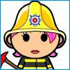
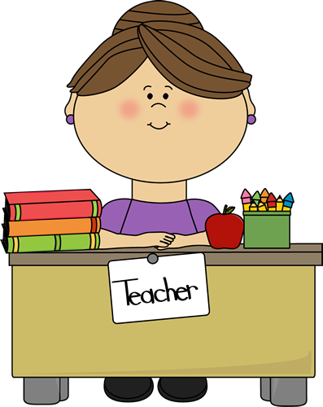

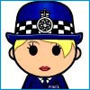
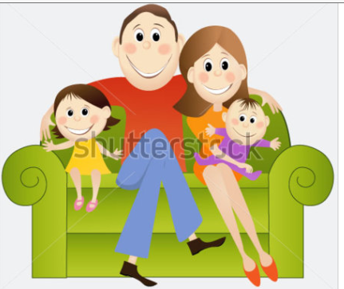

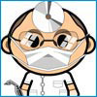
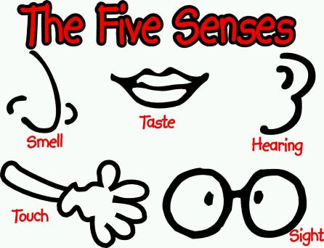

Autumn – Reception
‘People Who Help Us’

Role play
- Home corner -cooking
- Dinosaur Park
ICT
- Take digital photos
- Games

Outdoor Area
- Role play – Home corner
- Fire Station
- Games
- Practise physical skills on the climbing areas
- Small world area
- Running, jumping, throwing, catching
- Bats and balls, hula hoops, stilts.
Understanding the World
- Talk about similarities and differences
- People significant to them
- Know different occupations
- Healthy foods
- Changes in the environment -Autumn walk
- Look at where they live – drawing a map
Numeracy

- Recognising numbers 1 – 5 and then 1 – 10
- Recognise amounts without counting them. Eg see 3 and know there are 3 without counting.
- Know different ways to make 5- 0+5, 1+4, 2+ 3, 3+2, 4+1, 5+0
- Counting forwards and backwards to 20 and beyond
- Estimating how many objects they can see and check
- Using mathematical language such as more or fewer to compare two sets of objects
- Finding the total number of objects in two groups by counting all of them
- Using mathematical names for 3D shapes and 2D shapes
- Describing position such as next to or behind.
Investigation Station
- Exploring different materials using the senses and describing their properties. Is it hard or soft? Is it waterproof? Is it transparent or opaque?
Cooking
- Fruit Tasting

Physical / Health and Self-Care
- To develop fine motor skills by encouraging children to fasten coats and zips independently
- Negotiate space when playing
- Holding tools correctly- pencils, scissors, play dough tools, water and sand tools
- To manage their own hygiene
- To know how to keep themselves safe

Music
- Listening skills
- Rhythm clapping
- Nursery rhymes
Homework
- The shared reading system allows your child the opportunity to share a book with parents, siblings, grandparents or other family members. They can change their book as they come in on a morning.
- Homework will be given on a Tuesday and returned on a Monday.
- Children need to read at least 3 times a week and comments need to be recorded in their reading record. Children will be given tokens and entered into a prize draw if they read at home 3 times. More reading more tokens!
To support your child at home you could: Encourage independence – Can they zip and fasten their coats up on their own? Are they using a knife and fork correctly to eat their food? Can they get themselves dressed and undressed?
Share stories with your children asking them simple questions about the story, getting them to anticipate what will happen next.
Practise counting to 20, recognising numbers to 20 and one-to-one correspondence counting.

Reading Area
- Dinosaurs
- People who help us
- Fire Station
- Non- Fiction books
- Poems

