Literacy
- Maintain attention and sit appropriately
- Listening and responding to ideas expressed by others in a conversation of discussion
- Answering ‘how’ or ‘why’ questions about their experiences
- Listening to range of stories
- To write name

Small World Play

- Recreate classroom situations
- Dolls house
- Dinosaurs
Creative Development
- Colour mixing
- Printing
- Collage
- Exploring textures
- Exploring different resources
- Paint rolling
- Play dough
- Junk modelling
- Making 3D models
- Observational drawing
Sand and Water
- Floating and sinking materials
- Filling and pouring
- Fine motor skills

Construction Area

- Mobilo
- Lego
- Magnetics
- Train track
- Stickle bricks
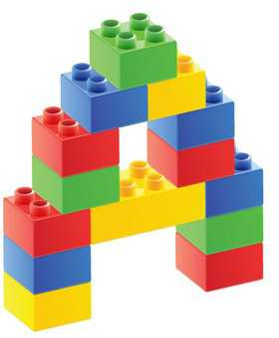

Music
- Listening skills
- Tuning ears in
- Rhythm clapping
- Singing nursery rhymes

Role play
- Home corner -Cooking and family.
Religious Education
- I am Special
- Feelings and Emotions
- I am a friend
- Sharing and caring
Physical / Health and Self-Care
- To develop fine motor skills by encouraging children to fasten coats and zips independently.
- Negotiate space safely when playing.
- Holding tools correctly- pencils, scissors, play dough tools, water and sand tools.
- Using their knives and forks correctly if eating lunch.
- To manage their own hygiene.
- To know how to keep themselves safe.


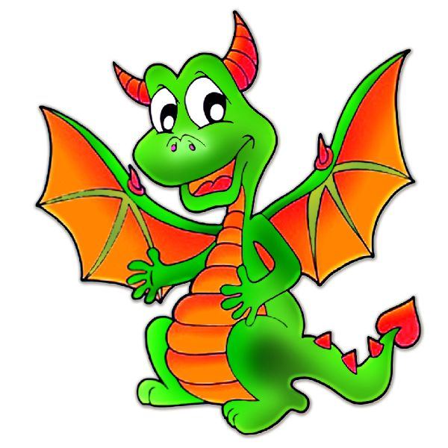
Autumn 1 – Nursery
Dinosaurs/ Ourselves
ICT
- Complete computer packages
- Games (Phonics, Maths etc.)
Outdoor Area
- Role play – Home corner
- Games
- Practise physical skills on the climbing areas
- Small world area
- Running, jumping, throwing, catching
- Bats and balls, hula hoops, stilts.
- Sand pit

Understanding the World
- Talk about similarities and differences
- People significant to them
- Changes – growing up.
- Our body
- Senses
- Healthy foods
- Friendships
- Sharing
- Changes in the environment –Autumn/weather
Numeracy

- Recognising numbers of significance
- Beginning to recognise 1 – 5
- One-to-one counting of objects
- Counting forwards and backwards to 10 and beyond
- Using mathematical names for 2D shapes
- Describing position such as next to or behind.
- Using mathematical language such as bigger, smaller ect.
Reading Area
- Familiarise them with stories in the area. (Fairy-tale stories, information books, traditional tales etc.)
- Dinosaur books
Cooking
- Healthy foods
- Dinosaur biscuits.
Investigation Area

- Senses – What can you feel? What can you smell? What can you see? What can you hear? What can you taste?
Here is an overview of what your children will be learning about this half term at nursery. You could use this to support your child’s learning at home. Thank you.
To support your child, you could:
- Practise self-care such as putting on their coats and fastening their zip, going to the toilet independently, using a knife and fork, washing hands.
- Read stories with your child and ask them simple questions about the story. Talk about the illustrations in a book and things they notice about it.
- Practise counting to 10, recognising numbers to 10 and one-to-one correspondence counting.

If you would like to know what we have been up to at Nursery, you can follow us on Twitter. This account is locked down and can only be viewed by people who follow the account and are accepted by a member of staff. You can follow us at: @HolyTrinity_nur

