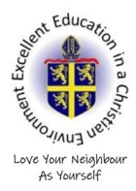


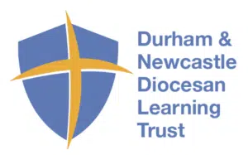
Religious Education Vision

MISSION STATEMENT
'To provide an excellent education in a Christian Environment'

SCHOOL AIMS
The ethos of Holy Trinity School is built upon love, 'Love your neighbour as yourself.' Luke 10:25-37

- To enable pupils to know about and understand Christianity as a living faith that influences the lives of people worldwide and as the religion that has most shaped British culture and heritage.
- To enable pupils to know and understand about other major world religions and non-religious worldviews, their impact on society, culture and the wider world, enabling pupils to express ideas and insights.
- To contribute to the development of pupils’ own spiritual/philosophical convictions, exploring and enriching their own beliefs and values.

Appropriate to their age at the end of their education in school, the expectation is that all pupils are religiously literate and as a minimum pupils are able to:
- Give a theologically informed and thoughtful account of Christianity as a living and diverse faith.
- Show an informed and respectful attitude to religions and non-religious worldviews in their search for God and meaning.
- Engage in meaningful and informed dialogue with those of other faiths and none.
- Reflect critically and responsibly on their own spiritual, philosophical and ethical convictions.’

The vision of RE at Holy Trinity is one that values:

- The acquisition and development of knowledge and understanding of Christianity and other principal world faiths;
- The understanding of beliefs, practises and values of Christianity and other faiths;
- The ability to make reasoned and informed judgements about religious and moral issues.

To work towards this vision and ensure a consistent approach to high provision of Religious Education throughout the school we aim;

- To reflect theologically and explore the ultimate questions and challenges of life in today’s society;
- To reflect critically on the truth claims of Christian belief;
- To see how the truth of Christianity is relevant today;
- To understand the challenge faced by Christians in today’s pluralist and post-modern society;
- To develop the skills to handle the Bible text;
- To recognise that faith is based on commitment to a particular way of understanding God and the world;
- To begin to develop their own commitments, beliefs and values;
- To develop a sense of themselves as significant, unique and precious;
- To experience the breadth and variety of the Christian community;
- To engage in thoughtful dialogue with other faiths and traditions;
- To become active citizens, serving their neighbor;
- To find a reason for hope in a troubled world;
- To understand how religious faith can sustain believers in difficult circumstances and in the face of opposition.

Role of the Subject Leader
To ensure that all members of the school community understand the vision of Religious Education at Holy Trinity and to lead, challenge and support all in achieving the vision by:

- Ensuring curriculum policies, guidelines and resources are well organised, reviewed, updated and easily accessible;
- Maintaining clarity of expectations in relation to planning, assessment and teaching and learning;
- Monitoring, evaluating and developing standards in teaching and learning;
- Identifying and addressing strengths and areas for development;
- Informing, supporting and providing development opportunities for all.

The role and responsibilities of governors are:
• Have a strategic oversight of RE
• Must ensure that provision and resources are available in accordance with the Trust Deed
• To contribute to and support RE, as a core subject of the school
• To contribute to and support the formation of a policy and curriculum for RE
• To ensure that the policy and curriculum prepares pupils with a religious understanding and sensitivity to take their place in the world
• To be a ‘critical friend’ in order to ensure the highest possible standards in teaching and learning in RE
• To ensure there is a curriculum that is inclusive and reflects breadth and depth
• To ensure curriculum time and staffing meet the requirements of the syllabus.

Religious Education Vision and Policy

Religious Education in Holy Trinity C of E Primary School lies at the very heart of the curriculum and as a school we strictly follow the Diocesan guidance:
- Governors adopted the Dioceses of Durham and Newcastle Syllabus for RE which reflects the National Framework for RE, the National Society Statement of Entitlement and the requirements of SIAMS.
- At least 5% of curriculum time is devoted to RE, ideally more. In practice, this means a starting point of 60 minutes per week for Key Stage 1 and 75 minutes per week for Key Stage 2.
- Christianity plays a central role in RE, taking up between two thirds of the time available.
- Appropriate teaching about other faiths and world views included in the final third. This ensure balance and breadth.

Teaching and Learning
The Religious Education curriculum maintains a balanced approach of Learning about Religion and Learning from Religion.

This can be expressed distinctively as:

Learning about Religion

We learn about:
- God who reveals the truth about himself and humanity through creation, the giving of the law, his action in history and through the prophets;
- God who reveals himself ultimately in Jesus his Son, living among us and dying and rising for us;
- God who reveals himself in his Spirit working in the living faith of the Church experienced through scripture, tradition and reason.

Learning from Religion

We learn from:
- An empathetic response to the Christian faith and a critical engagement with it;
- Responding personally to the stories and teachings of Jesus Christ;
- Examples of Christian living which give priority to the values of unconditional love, forgiveness, reconciliation, justice, compassion and faith.

It is entirely appropriate and necessary in today’s world that children should be encouraged to foster a respect for the followers of the other world faiths. It is essential that this respect is based on an accurate and sympathetic understanding of those faiths.
Therefore RE in Holy Trinity C of E Primary School also helps pupils to:
- Learn about other faiths, their beliefs, traditions and practices and from them through encounter and dialogue;
- Recognise and respect those of all faiths in their search for God;
- Recognise areas of common belief and practice between different faiths;
- Enrich and expand their understanding of truth while remaining faithful to their own tradition;
- Enrich their own faith through examples of holy living in other traditions.

Religious Education in Holy Trinity C of E Primary School enables:
- Pupils and teachers to talk openly and freely about their own personal beliefs and practice without fear of ridicule;
- Pupils to make excellent and appropriate progress in their knowledge and understanding of Christianity;
- Pupils from Christian families to talk openly about their beliefs and values in lessons and to grow in their faith;
- Pupils from other faith backgrounds to understand and be encouraged in their faith;
- Pupils with no religious background to be given an insight into what it means to be a person of faith;
- Pupils of all backgrounds to have a safe place to explore the ultimate questions and challenges of life in today’s society.

Planning and Assessment
CHEPlanning of Religious Education follows guidance set out by Durham/Newcastle Diocese advisor, Lisa Fenton, and is based around key questions and key experiences. Progression and differentiation are evident throughout and relate to the ‘Learning about Religion’ and ‘Learning from Religion’ guidelines. Planning always includes references to the Bible and levels of understanding. Planning also offers opportunities for assessment throughout and highlights available resources to be used at specific times.

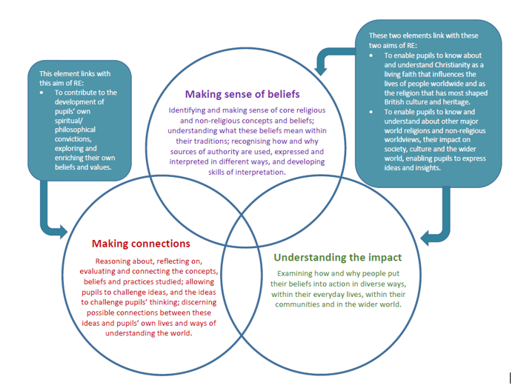

This syllabus is designed to develop and deliver excellence in RE. This syllabus sets out an approach to teaching and learning, to help pupils encounter core concepts in religions and beliefs in a coherent way, developing their understanding and their ability to hold balanced and informed conversations about religions and beliefs. The syllabus is underpinned by three core elements, which are woven together to provide breadth and balance within teaching and learning about religions and beliefs, thus supporting the aims of RE.
Teaching and learning in the classroom will encompass all three of the elements below, allowing for overlap between elements as suits the religion, concept and question being explored.

ASKKKK

These elements set the context for open exploration of religions and beliefs. They offer a structure through which pupils can encounter diverse religious traditions, alongside non-religious worldviews, presenting a broad and flexible strategy that allows for different traditions to be treated with integrity. These elements offer a route through each unit while also allowing for a range of questions reflecting approaches from religious studies, theology, ethics, sociology and philosophy.


Understanding Christianity: Text, Impact, Connections

Making sense of the text: Developing skills of reading and interpretation; understanding how Christians interpret, handle and use biblical texts; making sense of the meanings of texts for Christians.

Making connections: Evaluating, reflecting on and connecting the texts and concepts studied, and discerning possible connections between these and pupils’ own lives and ways of understanding the world.

Understanding the impact: Examining ways in which Christians respond to biblical texts and teachings, and how they put their beliefs into action in diverse ways within the Christian community and in the world.
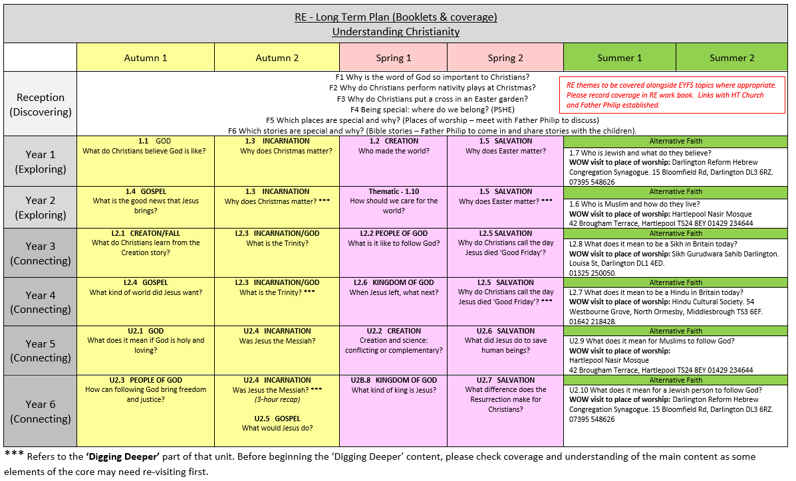

RE in KS1:
Pupils will develop their knowledge and understanding of religious and non-religious worldviews, recognising their local, national and global contexts. They will use basic subject-specific vocabulary. They will raise questions and begin to express their own views in response to the material they learn about and in response to questions about their ideas.

RE in KS2:
Pupils will extend their knowledge and understanding of religious and non-religious worldviews, recognising their local, national and global contexts. They will be introduced to an extended range of sources and subject-specific vocabulary. They will be encouraged to be curious and to ask increasingly challenging questions about religion, belief, values and human life. Pupils will learn to express their own ideas in response to the material they engage with, identifying relevant information, selecting examples and giving reasons to support their ideas and views.

All classes work closely with our Church Holy Trinity and are grateful for the enhanced knowledge Father Philip brings to our school. He frequently visits school for updates and CPD personally, as well as supporting our staff and pupils in the delivery of Religious Education.

We have also planned visits to other places of worship and in the summer term, each class is provided details to arrange a visit to a place of worship from an alternative faith. This provides a valuable experience for the pupils and enhances experiential learning, giving context to their unit of work. This also helps develop mutual respect between differing religions and communities, thus allowing empathy and deeper understanding.

Early Years
The Early Years Foundation Stage (EYFS) describes the phase of a child’s education from birth to the end of the reception year at the age of five. RE is statutory for all pupils registered on the school roll. The statutory requirement for RE does not extend to nursery classes in maintained schools. RE forms a valuable part of the educational experience of children throughout the key stage. In the EYFS curriculum learning does not fit into boxes: play-based and child-centred approaches will encourage the learning to follow where the child’s interest and curiosity leads.

The Diocesan Syllabus for RE sets out experiences and opportunities and appropriate topics for children in the Foundation Stage. The suggestions made for EYFS RE are good learning in themselves. These also connect to the EYFS 7 areas of learning.
Planned teaching experiences will support children’s learning and development needs identified through holistic assessment. Good Early Years teaching stems from children’s own experience and so many practitioners will find ways to draw on the wealth of religious or spiritual experiences that families may bring with them.
The EYFS statutory framework also outlines an expectation that practitioners reflect on the different ways in which children learn the characteristics of effective learning:

- Playing and exploring - children investigate and experience things, and ‘have a go’
- Active learning - children concentrate and keep on trying if they encounter difficulties, and enjoy achievements
- Creating and thinking critically - children have and develop their own ideas, make links between ideas, and develop strategies for doing things

What do pupils gain from RE in this age group?
RE sits very firmly within the areas of personal, social and emotional development and understanding the world. The framework enables children to develop a positive sense of themselves, and others, and to learn how to form positive and respectful relationships. They will do this through a balance of guided, planned teaching and pursuing their own learning within an enabling environment. They will begin to understand and value the differences of individuals and groups within their own immediate community. Children will have opportunities to develop their emerging moral and cultural awareness.

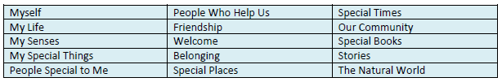
Themes which are considered when planning opportunities for RE work include the following:

RE is compulsory in Reception Year
A similar approach is adopted for reception pupils. For teaching to be good quality, the questions, learning outcomes and content need to be taught together. There may also be cross-curricular links. We ask that they cover the following questions:

F1 Why is the word of God so important to Christians?
F2 Why do Christians perform nativity plays at Christmas?
F3 Why do Christians put a cross in an Easter garden?
F4 Being special: where do we belong? (PSHE)
F5 Which places are special and why? (Places of worship – meet with Father Philip to discuss)
F6 Which stories are special and why? (Bible stories – Father Philip to come in and share stories with the children).

Teacher Assessment:
Ongoing monitoring and evaluations allow teachers the opportunity to gather information, address misconceptions and inform next steps. Assessment information shows teachers who is meeting outcomes or not yet meeting outcomes. Pupils may find some elements of the block more challenging, teachers can make short notes of this for their next teacher.

Assessment judgements are decided by:
- Observations of children engaged in activity;
- Pupil self/peer assessment;
- Dialogue with individuals or groups;
- Dialogue with ‘experts’ and support staff;
- Evaluation from planning documents.

Making progress
The subject leader sets basic and challenging targets for all learners, every learner has a target of working at ‘age-related’ in their current year group and many have aspirational targets to be ‘greater depth’. Teachers are responsible for setting ongoing targets for children in their guidance. Targets are communicated throughout the year and appear on the end of year report.

At the end of each academic year a learning dialogue is opened between professionals to discuss the next steps for the beginning of the new academic year. The Religious Education book continues through school with the children, which tracks progression and achievements along their journey. You can see evidence of Biblical texts and stories and also their interpretation and links to the world around them. We encourage all children to be curious and reflective within tasks.

Withdrawal
‘The Worship and Religious Education provided by the school is in accordance with the Church of England or Methodist Church Foundation. This foundation is also reflected in the curriculum and the whole life of the school community. Since the conduct of the school as a whole reflects the Church of England or Methodist Church ethos, removal of pupils from Worship and/or Religious Education (as parents are legally entitled to do) cannot insulate them from the religious life of the school.’

Governors
There is a named governor linked to Religious Education who plays a key role in monitoring and evaluating RE across the school through discussions and feedback from subject leader. The named governor is currently Father Philip Bullock.

Updated: September 2023
Review September 2024
Completed by: Mrs L Bull

