

Holy Trinity C of E Primary

Love Your Neighbour
As Yourself
NEWSLETTER – 26th April 2024
www.holytrinitycofeseatoncarew.co.uk

E-mail: admin@hpoolholytrinity.org.uk
@htseaton (twitter)

Dates for your Diary
6th May Bank Holiday
8th May Church
9th – 10th May Y4 Camping
13th-16th May Y6 SATS
15th May Church
17th May Year 5 Class Worship
21st May PTA Summer Disco
EY / KS1 4PM-5PM
KS2 5.15PM- 6.15PM
22nd May Church
24th May Year 4 Class Worship
24th May School Closes for Half Term
6th June School Opens
7th June Year 3 Class Worship
14th June Year 2 Class Worship
19th June Church
26th June Church
1st-3rd July Y6 Edinburgh Residential
5th July Reception Class Worship
10th July Church – Years 6 Leavers service
19th July Year 6 Class Worship
19th July School Closes for Summer holidays

Bravery Award
We would like to say a huge congratulations to one of our Year 3 Pupils, Isabella Amos, for receiving a “Brave Hearts of the North East Award” on Thursday 25th April at St James’s Park. Isabella was nominated for the award by the Cardiac Nurses from Freeman Hospital for her inspirational courage and strength.

Quad Kids Athletics
Some of our Y4 pupils represented our school at Quad Kids athletics this morning. There was a range of events to compete in such as running, throwing, jumping and relay. They were excellent representatives of our school and showed excellent sportsmanship. Well done.

PTA Summer Disco Tuesday 21st May
Please see below with information regarding the summer disco.
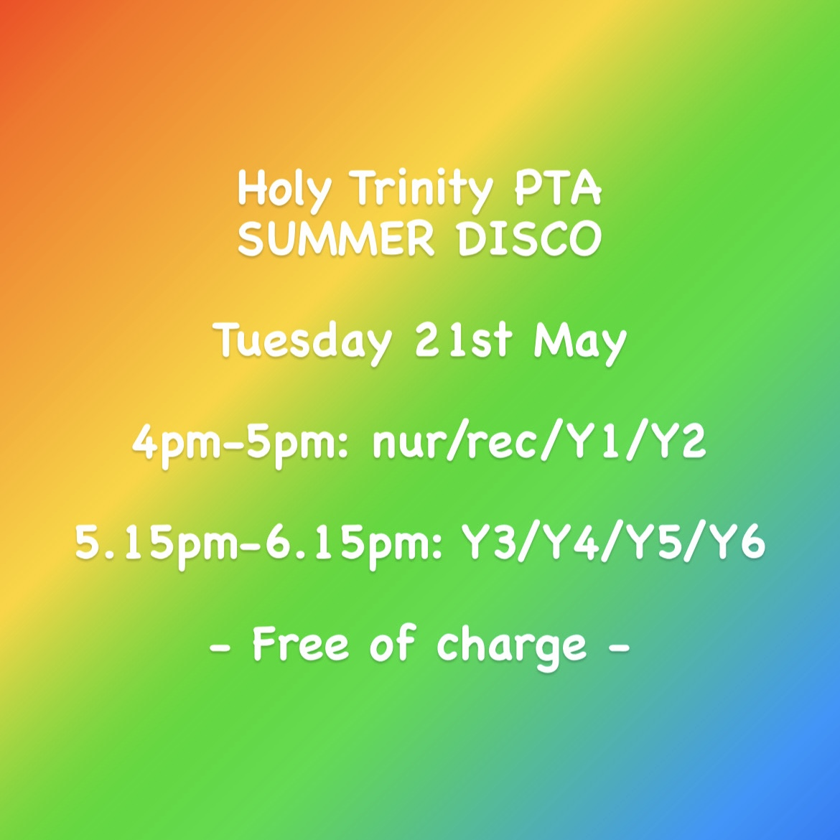

Pupil Data Entry Forms
Today, we will be sending home new revised pupil data entry forms to collect additional data as detailed in the attached letter. On receipt of the new form please complete, IN FULL, all sections and both sides and return it back to school as soon as possible. A separate form needs completing for each child.

Oversized Hair Bows
Can we please ask that pupils refrain from wearing oversized hair accessories for school as these are not part of our school uniform. Please also see below a reminder of our school policy for hairstyles :
Hair: For ALL pupils.
- If hair is worn long (below shoulder length), it must be tied up or back, for hygiene reasons. Outrageous and inappropriate hairstyles such as mohawks, tramlines, rats tails, skin fades, spikes, shapes, colours and hairstyles created by gel/wax are not acceptable in school.

School Nurse Drop in Session – Tuesday 30th April 2.30-3.30pm
If you wish to attend the above drop in session could you please email admin2@hpoolholytrinity.org.uk in advance in order for us to confirm numbers.

