

Holy Trinity C of E Primary

Love Your Neighbour
As Yourself
NEWSLETTER – 3rd May 2024
www.holytrinitycofeseatoncarew.co.uk

E-mail: admin@hpoolholytrinity.org.uk
@htseaton (twitter)

Dates for your Diary
6th May Bank Holiday
8th May Church
9th – 10th May Y4 Camping
13th-16th May Y6 SATS
15th May Church
17th May Year 5 Class Worship
21st May PTA Summer Disco
EY / KS1 4PM-5PM
KS2 5.15PM- 6.15PM
22nd May Church
24th May Year 4 Class Worship
24th May School Closes for Half Term
6th June School Opens
7th June Year 3 Class Worship
14th June Year 2 Class Worship
19th June Church
26th June Church
1st-3rd July Y6 Edinburgh Residential
5th July Reception Class Worship
10th July Church – Years 6 Leavers service
19th July Year 6 Class Worship
19th July School Closes for Summer holiday

PTA Summer Disco Tuesday 21st May

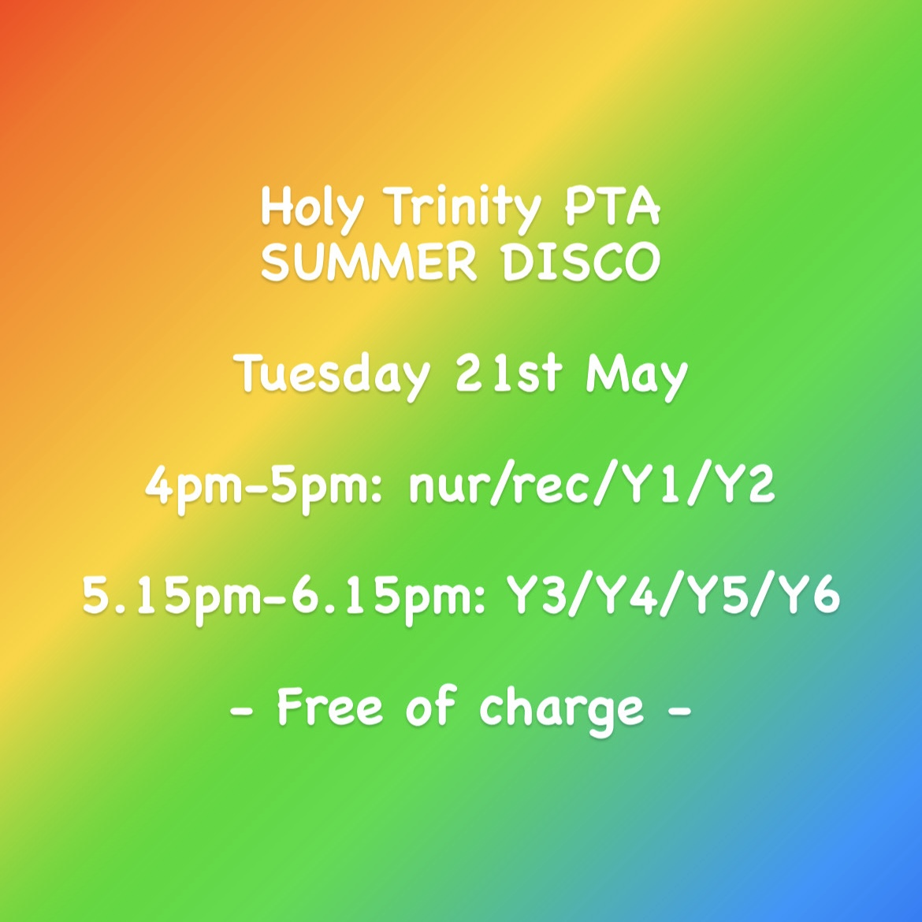

Bank Holiday Monday 6th May 2024
School will close today and reopen on Tuesday, 7th May 2024, following the May bank holiday.

Disney Shooting Stars Football Festival
On Thursday this week, some of our Year 1 and Year 2 pupils attended a Disney Shooting Stars Football Festival for girls held at High Tunstall School. Pupils dressed up in Disney outfits and took part in lots of different activities including team games and learning new ball skills. A good time was had by all.

