

Curriculum Coverage for Year 2

Summer Term

Curriculum Area | Coverage
English  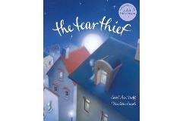  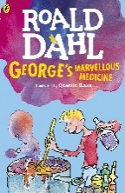  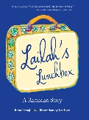 | Reading – Children will be learning to read most words with pace and accuracy, without overt sounding out. They will be learning a range of new punctuation in texts and be able to self-correct when they make an error. They will take part in regular Early Reading sessions across the week, where they will work on decoding, prosody and comprehension. We have a purpose for reading book, as well as a whole class reading for pleasure book.  Home reading books are closely matched to their individual phonic ability and children should be beginning to read them fluently with pace, recognising taught sounds and tricky words. Children should be able to confidently decode 90% of the book without too much support. They should also begin to have a deeper understanding of the use of punctuation. E.g. when they see a full stop, they must take a breath. Please highlight and discuss any punctuation in their book. Some children will be bringing a book home linking to something we use in school called Accelerated Reader. This gives them the opportunity to check their understanding of that book through a quick quiz before changing it. Not all children are accessing this yet.  Writing – We delve into the creative world of reading and writing through our love of texts! This allows us the opportunity to write for a range of purposes (letters, character descriptions, story writing, poetry etc.) Through a range of interesting text types, we explore writing for a range of genres and purpose. Some of the books we’re covering this term are in the box to the left.  Grammar Punctuation and spelling (GPS) – Children will be focusing on a range of Year 2 GPS skills. Children will be given weekly spelling lists to work on at home as well as school and will be tested on a Monday.
  Mathematics | Counting and Times tables – To be able to recall and use multiplication and division facts for the 2, 5 and 10 multiplication tables. Following our White Rose Mastery Maths approach, our units for this term will be:    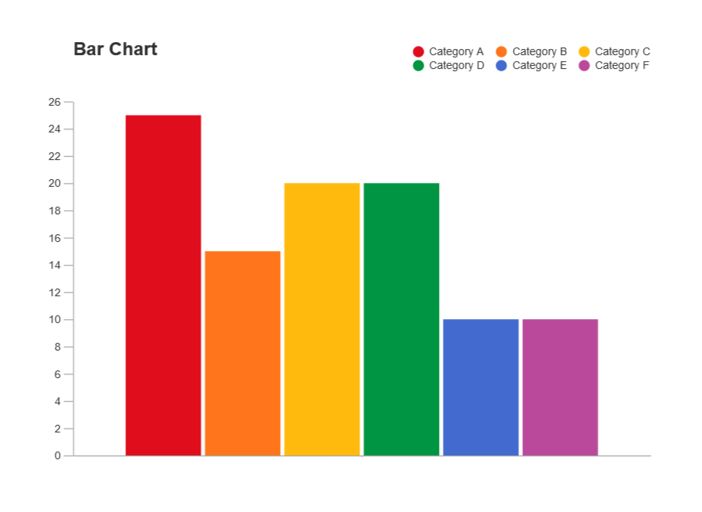  - Measurement - Time  - Statistics  - Geometry – Position & direction
  Science |   - Growing up (Life Cycles)  - Planting – Bulbs & seeds  - Wildlife
  Religious  Education | Within RE, we will be exploring the alternative faith unit: ‘Who is Muslim and how do they live?’  We will be visiting Church for regular services (which you are more than welcome to attend) and the children will take part in a class worship during alternative Wednesday mornings. Whole School collective worship takes place each day.
    Computing | Digital Literacy/ Information Communication Technology  - Using the internet purposefully - Research a given topic, copy and paste text, take photos (including screenshots) and save images, use of technology beyond school.  - Creating content - Manipulate text and images, using emoticons to convey meaning, thinking carefully about the layout of content.
Curriculum      Art and Design  D&T  History/ Geography |   History - What was Victorian life like? How have hospitals changed? TRIP – Beamish Museum.  Art – Craft and design – map it out. We will be following our scheme of work (KAPOW).  Design – Structures. Freestanding structures.
  Music |     Music sessions will be covered weekly by Apollo Arts.  Summer 1 - Music through the decades (singing & analysis)  Summer 2 - Music Technology & Composition
  P. E | Summer 1 – Cricket & Gymnastics  Summer 2 – Sports Day Games & Hit, Catch, Run  Sessions are taught by both Mr Murray and Mrs Bull.  Children also complete daily physical activities to ensure we are frequently active across the school day.
  Homework | Spellings: These will be handed out weekly on a Tuesday and children will be tested the following Monday. Please use the worksheet inside the book provided to practice, as well as discussing and demonstrating neat handwriting. You also have the resource Spelling Shed, where weekly spellings are uploaded.  Counting/Times tables that your child needs support with are x2, x5, x10, x3.  Their home reading book is to be shared at least 3 times a week and comments made in their reading diary regularly to share progress/targets. Homework will either be set virtually (Seesaw) or come home in their homework folder on a Tuesday and be completed and handed back by the Monday of the following week.

Within all curriculum areas we ensure that all children are able to access the curriculum including those with SEN and be appropriately challenged.

Thank you for your continued support,

Mrs. Bull and Miss Lavelle

