

Holy Trinity C of E Primary
NEWSLETTER- 9th May 2025
www.holytrinitycofeseatoncarew.co.uk

E-mail: admin@hpoolholytrinity.org.uk
Love Your Neighbour
As Yourself

Dates for Your Diary
12th -15th May Y6 SATS
21st May Church
23rd May Year 2 Collective Worship
13th June Year 3 Collective Worship
20th June Year 4 Collective Worship
18–20th Jun Y6 Edinburgh Residential
25th June Church
27th June Year 1 Collective Worship
2nd July Church
3^{rd -}4th July Y4 Camping
4th July Reception Collective Worship
9th July Year 6 Leavers Service in Church
11th July Apollo Arts Live Music Event and Summer Fair Afternoon
17th July Year 5 Collective Worship
18th July Year 6 Leavers Assembly (AM)
21st July School Closes for Summer
1st Sep School Opens
24th Oct School Closes for Half Term
3rd Nov School Opens
19th Dec School Closes for Christmas
5th Jan School Opens

Holy Trinity Live Music Event- Friday 11th July
We would like to invite parents/guardians (2 adults per child) to join us for our Holy Trinity Live music event and Summer Fair afternoon. Our music event will feature all classes from Nursery to Year 6, who will be performing “Music through the Decades”, with a live band and our music teachers from Apollo Arts. The event starts at 1pm and will run for approximately 1 hour, followed by our Summer Fair afternoon 2-3pm. If you are able to join us, please bring deckchairs/picnic blankets and sit down and relax as the children enjoy performing and sharing what they have been learning in music lessons. All children will then return to class to collect their belongings, where you will be able to pick your child up and take them around the Summer Fair. Don’t worry if you cannot make this event as children that cannot be collected early will remain in school to be picked up at the normal time.

Hair School Policy for All Pupils.
If hair is worn long (below shoulder length), it must be tied up or back, for hygiene reasons. Outrageous and inappropriate hairstyles such as mohawks, tramlines, rats tails, top knots, skin fades, spikes, shapes, hair dye, colours, bleach, highlights and hairstyles created by gel/wax are not acceptable in school.

Year 1 Visit to Beamish
On Wednesday this week, Year 1 visited Beamish to provide a real-life experience of what life was like in the Northeast England in the 1950s. The trip entailed a visit to the houses, the shops (hairdressers, toy shop, electrical shop and the record shop), the miner's cottages and police station. They also visited the cinema and watched the adverts from that era, a cartoon and a movie about life in those days. The children enjoyed taking part in a toys workshop where they got to explore and play with toys from over the past one hundred years. It was the perfect start to their history topic which is comparing life when Queen Elizabeth II had her coronation to life today.

Year 2 Seaton Carew Railway Artwork
In the Autumn Term, Year 2 created some artwork to celebrate the 200th Anniversary of the Stockton & Darlington Railway as part of their history topic. Organisers of the celebration approached school to use this artwork to create boards for the train station to commemorate SD200 and were delighted with the work they received, and they have created the board (see below) - it is currently on display at Seaton Railway Station, so please keep an eye out for it! The organisers of the event have invited pupils in Year 2 to attend a celebration at the railway station for photographs by the local press and to meet a representative from Northern Rail. We are very proud to be taking part in this special event based on local history!
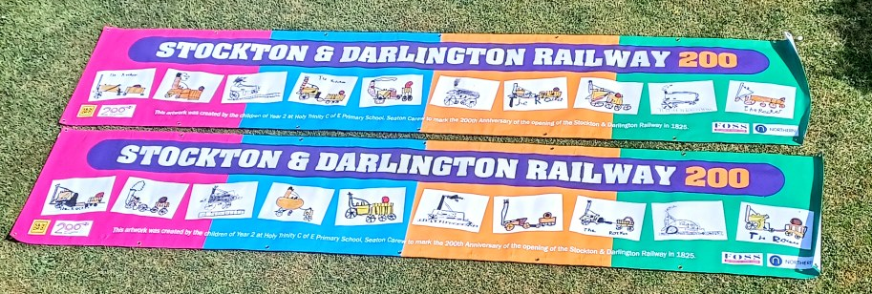

Safety Issues with Cycles /Scooters
We are having a major issue at the school gate with children riding their bikes and scooters to school on a morning. For the safety of everyone can we please ask that children on bikes and scooters stand against Dodds Field to allow pedestrians through the gates first. We have the facility for children to store bikes and scooters on site. If your child would like to come to school on their bike or scooter, please ask for a contract from the office. Your child will need to wear a helmet and lock their bike/scooter up whilst it is on school grounds.

Y6 SATS
Good luck to our Year 6 pupils who will be carrying out their SATS next week.

