Religious Education Policy



**Understanding Christianity**

**The reason for Understanding Christianity:**

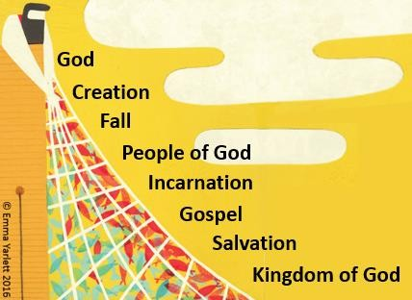To support pupils in developing their understanding of Christianity, as a contribution to their understanding of the world and their own experience within it.

***Aims of Understanding Christianity***

To enable pupils to know about and understand Christianity as a living world faith, by exploring core theological concepts.

To enable pupils to develop knowledge and skills in making sense of biblical texts and understanding their impact in the lives of Christians.

To develop pupils’ abilities to connect, critically reflect upon, evaluate and apply their learning to their own growing understanding of Christianity, of religion and belief more widely, of themselves, the world and human experience.

***What is being taught?***

Understanding Christianity resources have selected and explore these eight concepts because they offer a coherent series of ideas that underpin Christian belief and practice. The ‘big story’ gives a context into which teachers and pupils can place the concepts as they encounter them in RE throughout the school.

The approach developed for Understanding Christianity is based on the use of core concepts of Christian belief, as expressed in the Bible and lived out in the lives of Christians today. The core concepts reflect a view that the Bible tells a ‘big story’ of salvation. The approach in RE is to revisit the core concepts throughout the different key stages, deepening pupils’ understanding and making the links to the overall ‘big story’ or ‘salvation narrative’.

This is not the only way to describe Christian thought and practice, and of course there is real diversity within Christianity itself, but it sets a good foundation for understanding the heart of the Christian faith.

The teaching and learning approach enables pupils to engage with a variety of Bible texts in order to explore how Christians understand the core concepts.

It explores ways in which Christians might live in the light of these texts, within the Christian community and in their individual lives. It allows pupils to reflect on some of the questions and puzzles that arise from the Bible, and to consider any implications or connections with their own lives and ways of understanding the world.

**The Big Frieze**



The frieze illustrates seven of the eight core concepts that are explored throughout the Understanding Christianity materials. Effectively, this image presents a view of the ‘big story’ of the bible- it is an artist’s response to the approach used in the Understanding Christianity resource materials.

The Big Frieze is designed to give teachers the opportunity to make pupils aware of the wider context of each concept, unit and text studied in Understanding Christianity. Reminding pupils regularly of where a particular text occurs within the ‘big story’, by pointing it out on the Frieze, helps to build up a coherent understanding of the core concepts and the relationships between them.

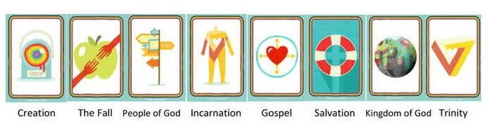

**What are the concepts and what do they mean?**

Pupils encounter concepts several times as part of a spiral curriculum- each encounter uses different key questions, texts and approaches. Understanding is reinforced and deepened through these ongoing encounters.

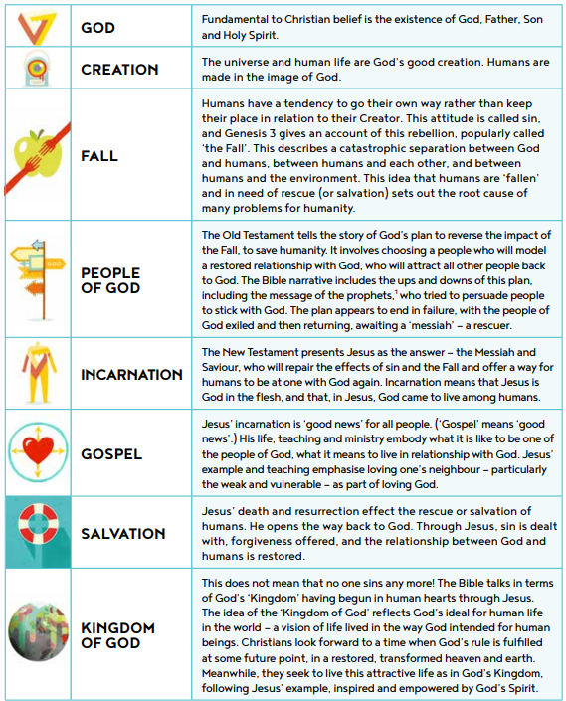

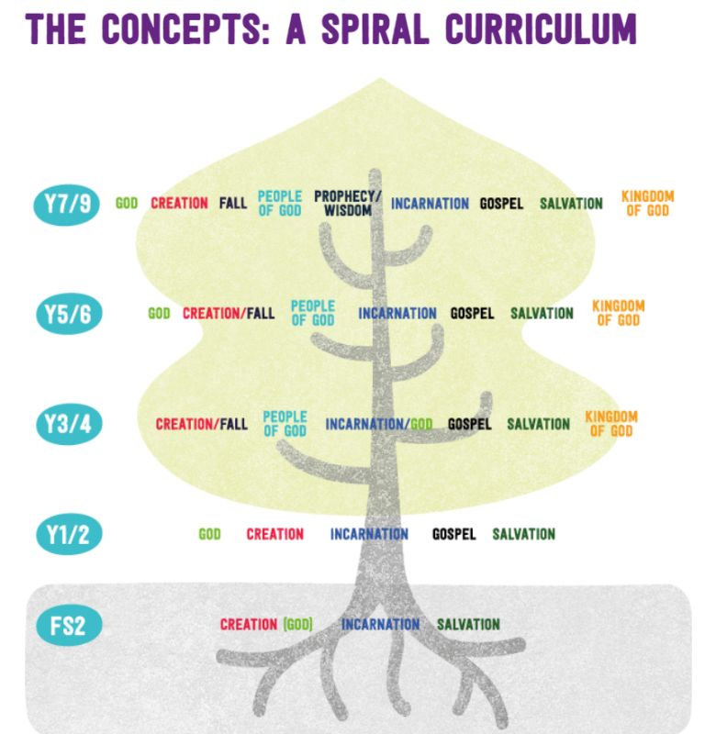

**Each of the three elements of the teaching and learning approach is important and pupils should make progress in all of them. Below are the end-of-phase outcomes related to each element. Each unit takes bullet points from these end-of-phase outcomes and applies them specifically to the unit questions.**

|  |  |  |  |
| --- | --- | --- | --- |
|  | **By the end of KS1**  **Pupils should be able to:** | **By the end of KS2**  **Pupils should be able to:** |  |
| **ELEMENT 1:**  **Making sense of the text**  **Developing skills of reading and interpretation; understanding how Christians interpret, handle and use biblical texts; making sense of meanings of texts for Christians** | * Recognise that God, Creation, Incarnation and Salvation are part of a ‘big story’ of the Bible. * Identify at least two different types of texts from the Bible; for example, a story, a parable, a gospel account of Jesus’ life, and instructions about how to behave. * Tell stories from the Bible and recognise a link with a concept; for example, Creation, Incarnation, Gospel and Salvation. * Give clear, simple accounts of what the texts mean to Christians. | * Order at least five key concepts within a timeline of the Bible’s ‘big story’. * List two distinguishing features of at least three different types of biblical text; for example, Gospel, parable, letter. * Make clear links between biblical texts and the key concepts studied. * Offer suggestions about what texts might mean and give examples of what the texts studied mean to some Christians | Exploring the Context  Where does this ﬁt in the ‘big story’?  Exploring Interpretations  Pupils’ views and a variety of Christian readings.  Exploring Purposes  How do Christians use this text?  Exploring Signiﬁcance  Why does this matter?  Unveiling the Concepts  How does this contribute to understanding key Christian ideas? |
| **ELEMENT 2:**  **Understanding the impact**  **Examining ways in which Christians respond to biblical texts and teachings, and how they put their beliefs into action in diverse ways within the Christian community and in the world** | * Give at least three examples of ways in which Christians use Bible concepts, stories and texts to guide their beliefs, in their individual lives and in their church communities. * Give at least three examples of how Christians put their beliefs into practice in church worship. | * Make simple links between Bible texts and concepts studied and how Christians live in their whole lives and in their church communities. * Describe how Christians show their beliefs in worship and in the way, they live. | How then, do Christians live...?  …in the Christian community?  Examining ways in which Church living grows out of biblical teaching.  ...in their everyday living?  Examining ways in which Christians apply the Bible day-to-day.  What impacts do Christianity and Christians have in the world?  Examining ways in which Christian belief and practice make a difference in the world.  How has this had an impact on how people see the world?  Examining the inﬂuence of Christian thought on 21st-century thinking and living. |
| **ELEMENT 3:**  **Making connections**  **Evaluating, reflecting on and connecting the texts and concepts studied, and discerning possible connections between these and pupils’ own lives and wats of understanding the world** | * Think, talk and ask questions about whether the text has something to say to them, exploring different ideas. | * Raise questions and suggest answers about how far the big ideas explored in the Bible and the concepts studied might make a difference to how pupils think and live. * Make links between some of the stories and teachings in the Bible and life in the world today, expressing some ideas of their own clearly. | Connecting Texts, Concepts and Christian Living  Developing understanding of the bigger picture.  Connecting Ideas Studied and Pupils’ Own Ideas  Using ideas studied to reﬂect on matters of personal concern.  Personal and Impersonal Evaluation  Allowing pupils to challenge ideas studied, and the ideas studied to challenge pupils’ thinking.  Examining Implications for Pupils’ Understanding of Self, World and Others  Discerning where there might or might not be value to be gained from ideas studied. |

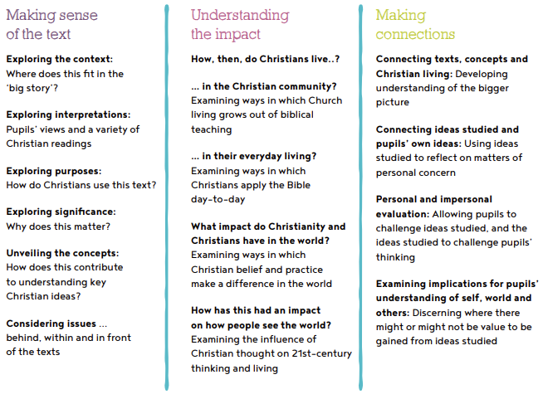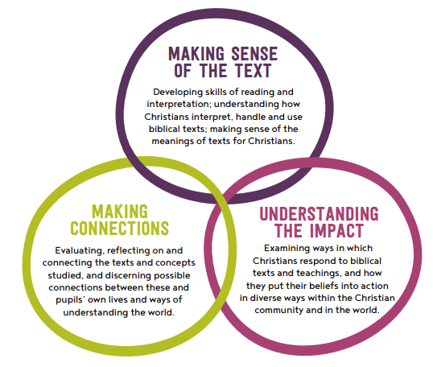

**RE can be delivered in flexible ways and further opportunities should be sought to** **develop RE in the curriculum for example through** **RE days, RE weeks, visits and other projects.**

* **RE is a core subject of the curriculum for all pupils.** The ‘basic’ school curriculum includes the National Curriculum, RE and Sex Education and in Church schools RE has the status of a core subject. The requirements of this Diocesan Syllabus are not subject to the flexibility of the Foundation Subjects. RE is a legal entitlement for all pupils in all year groups throughout their schooling, from Reception year up to and including Key Stage 5.
* **RE is separate from collective worship.** Curriculum time for RE is distinct and separate from the time we spend within collective worship.
* Flexible delivery of RE: We may deliver RE-themed days or week of study to compliment, but this would not replace the regular weekly programme of lessons.
* In EYFS, teachers can highlight the opportunities they are providing to integrate RE into their children’s learning.

Whilst schools are expected to make their own decisions about how to divide up curriculum time, we will ensure that sufficient time is given to RE so that pupils can meet the expectations set out in the Diocesan Syllabus to provide coherence and progression in learning.

# How do we know our curriculum is effective?

* **High Quality Outcomes:** Pupils should be articulate and knowledgeable about their learning. The work produced will be well-presented in RE books, showing a range of tasks.
* **Assessment:** Assessment in RE will take place in line with the school’s assessment policy. Teachers should assess pupils’ understanding throughout teaching and plan subsequent teaching and learning in response to this. Assessment may vary from teacher observation or questioning, to marked activities. We also recognise that some of the most important learning in RE cannot be formally assessed (e.g. spiritual development). At the end of each enquiry, pupils will produce a documented response to the enquiry question. We complete ‘end of unit assessments’ during the final session of the unit. This is a great summary of learning and celebrating new knowledge acquired. Teachers can then identify progress and address gaps/misconceptions.
* **Monitoring:** Monitoring activities may include pupil interviews, informal discussion with staff, examination of planning and learning visits in order to assess the effectiveness of the curriculum in meeting the intent. Thee Subject Lead can use the information gathered to organise effective CPD to support staff with subject knowledge, planning and delivery.

**Useful Websites:** The following websites may be useful:

* + [BBC Bitesize: RE:](https://www.bbc.co.uk/bitesize/subjects/z7hs34j) Guides and videos for religious knowledge.
  + [BBC Teach: RE:](https://www.bbc.co.uk/teach/ks2-religious-studies/z6pbqp3) Guides and videos for religious knowledge.
  + [Understanding Christianity:](https://www.understandingchristianity.org.uk/) Site and background for UC. More detailed resources are also available from the subject leader.
  + <https://www.natre.org.uk/primary/primary-re-curriculum/> CPD, news/updates, support with delivery.

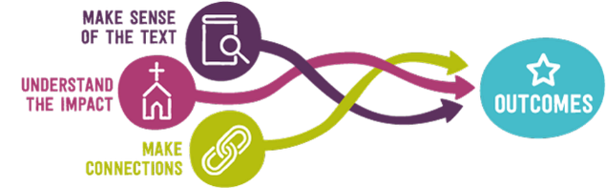

**The role and responsibilities of governors are:**

* + - Have a strategic oversight of RE
    - Must ensure that provision and resources are available in accordance with the Trust Deed
    - To contribute to and support RE, as a core subject of the school
    - To contribute to and support the formation of a policy and curriculum for RE
    - To ensure that the policy and curriculum prepares pupils with a religious understanding and sensitivity to take their place in the world
    - To be a ‘critical friend’ in order to ensure the highest possible standards in teaching and learning in RE
    - To ensure there is a curriculum that is inclusive and reflects breadth and depth
    - To ensure curriculum time and staffing meet the requirements of the syllabus.

*Updated: July 2025*

*Completed by: Mrs N Wager*