Holy Trinity C of E Primary School

Computing Policy

Date of Review: October 2025
Next date of Review: October 2026
Our School Vision
‘Love your neighbour as yourself.’
Matthew 22:36-40 “Teacher, which is the greatest commandment in the Law?” Jesus replied: “Love the Lord your God with all your heart and with all your soul and with all your mind. This is the first and greatest commandment. And the second is like it: Love your neighbour as yourself.”
At Holy Trinity, positive, caring relationships are the foundation of our school community, woven through everything we do. In our school, everyone is valued and learns to value one another. Children, staff, and families are recognised and celebrated as unique individuals — each one loved, supported, and respected for who they are. Jesus’ teaching supports us to see the value in others, to be compassionate and to create an environment where everyone can flourish and achieve their full potential.
We recognise that our school community is part of a larger, diverse world, and we are committed to fostering an environment that is welcoming, inclusive, and accepting of all. At Holy Trinity, we nurture curious and motivated learners who take joy in discovery as they explore the world around them. We encourage our pupils develop into responsible global neighbours who respect, appreciate, and embrace the differences that make each of us unique.
We support our Holy Trinity family to flourish by nurturing their spiritual journey through:
- Looking in with self-reflection, to love and value themselves as a unique child of God with self-respect and honesty.
- Looking out with compassion and service to seek justice, peace, and care for all people and the planet we share.
- Looking up with wonder and gratitude. We consider being a part of something greater than ourselves by taking time to pray, reflect, and be still.
Our school values:
Respect – The Parable of the Good Samaritan
Luke 10:25-37 teaches that compassion, and neighbourly love should be extended to everyone, irrespective of background or perceived differences.
Community – The Parable of the Lost Sheep
Matthew 18: 10–14 teaches us the importance of community and belonging. God, like the shepherd, desires for all to be part of the flock, experiencing the joy of being connected and cared for.
Responsibility – The Parable of Jesus feeding the 5000
John 6.1-13 teaches us that Jesus notices and cares about the everyday needs of all people.
By fostering an inclusive community and working in partnership with Durham and Newcastle Diocesan Learning Trust and the Church of England, we are empowering our children to live full lives, reaching their potential and helping others to do the same. Through our spiritual development and our commitment to these Christian values, we encourage children to not only see the world through a broader lens but also actively contribute to making it a more inclusive and compassionate place. Our school is a place where respect, community, and responsibility guide our actions and help us live out the teaching to love our neighbour as ourselves.
Durham and Newcastle Diocesan Learning Trust’s vision: "Every child matters and no child is ever left behind..."
The Church of England vision: "Live life to its fullness."

Intent
We recognise that our children are citizens of the digital age, and we intend to provide them with the skills and concepts needed to thrive in a future that is increasingly dependent on computational thinking and creativity. We aim to inspire pupils to become curious and explorative thinkers – to think like computing experts. This involves:
- using the internet in a safe and respectful way
- understanding how and where to seek help and support
- writing and debugging code successfully and with confidence
- analysing problems in computational terms
- competently and creatively using information and communication technology
- recognising the use of technology in the wider world

Aims
- Pupils are responsible, fluent and confident users of information and communication technology.
- Children have a wide range of opportunities to create a range of content using digital devices.
- Children are digitally literate and are suitably prepared for life as active participants in the digital world.
- Children are able to create programs and solve problems in computational terms.
- Children to become creators of content for other citizens in the digital world.
- Children develop the confidence to question and observe, measure and record data in a variety of ways and analyse and present their findings.

Kapow Primary
To support the delivery of the Computing curriculum, Holy Trinity follows Kapow Primary Computing scheme. This scheme supports teachers in their subject knowledge and development of computational skills, enabling the delivery of engaging, well-informed lessons with confidence. The National Curriculum organises the teaching and learning of Computing under three strands:
- Computer science: How computers and computer systems work and how they are designed and programmed.
- Information Technology: How you apply the knowledge and understanding how to purposefully create and make things
- Digital Literacy: The understanding, the purpose and implications.
These strands run through each Kapow Computing unit.
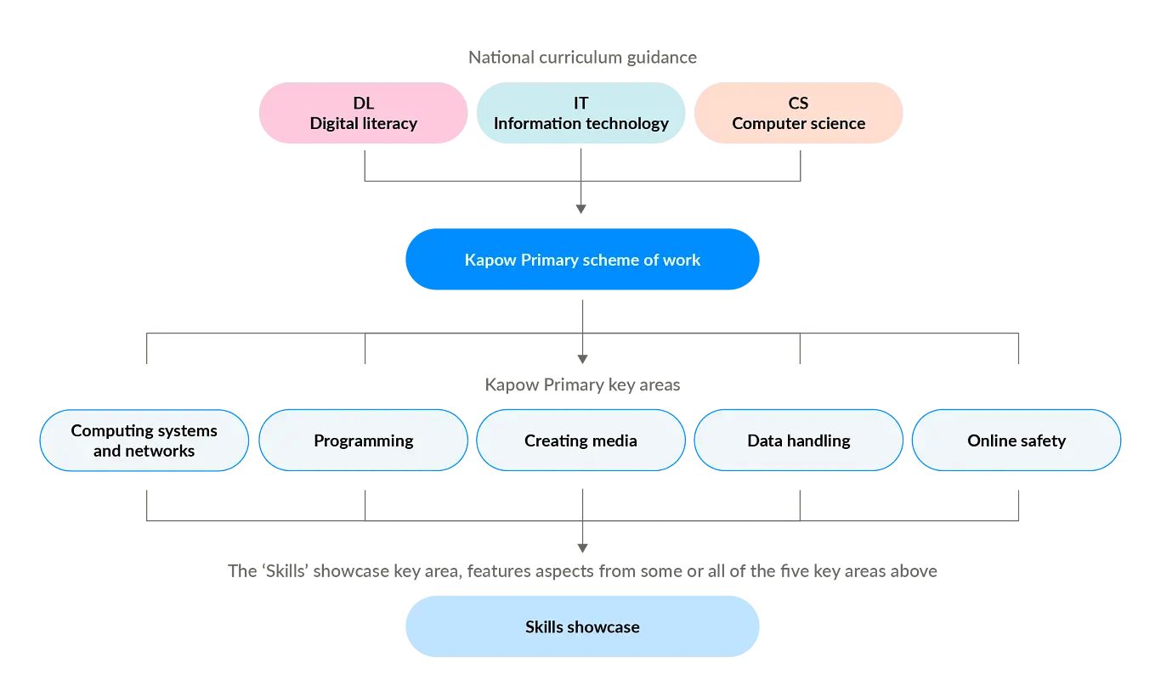
These strands ensure a balanced coverage of the different aspects of computing, supporting the development of both substantive knowledge (e.g. understanding algorithms) and disciplinary knowledge (e.g. applying skills to a program). New learning is weighted towards the beginning of each key stage, allowing the subject-specific knowledge to be constantly revisited through subsequent year groups. Some lessons are practical, whereas others focus on developing children’s oracy through ‘unplugged’ Computing lessons. Lessons encourage discussion, explanation and collaborative problem-solving, allowing pupils to question processes, listen to and build on the ideas of others.

The Kapow Computing scheme is continually evaluated and updated through regular curriculum reviews, feedback from schools and updates within the latest subject-specific research and pedagogy.

For the first year of implementation, Kapow advises to use a ‘catch-up’ curriculum to ensure any gaps in children’s knowledge are addressed and a solid foundation of essential knowledge and skills are built before proceeding to more advanced lessons.

Role of the Subject Leader
Computing is led by Miss Fender who is supported by One IT Technical Support staff (once a week). The role of the team is to ensure that all members of the school community understand the vision of Computing at Holy Trinity and to lead, challenge and support all in achieving the vision by:
- Ensuring curriculum policies, guidelines and resources are well organised, reviewed, updated and easily accessible.
- Maintaining clarity of expectations in relation to planning, assessment, teaching and learning.
- Developing standards in teaching and learning.
- Identifying and addressing strengths and areas for development.
- Informing, supporting and providing development opportunities.
- Ensuring that safety online systems are current and robust.

Assessment and Recording
Teachers assess children’s skills in Computing by making judgments as they observe them during lessons. Formative assessment is very important in Computing and ‘live’ feedback is encouraged. At the end of each unit, children complete a ‘quiz’ style assessment consisting of nine subject-specific knowledge questions and one open-ended, reasoning question. Scores are tracked on an Excel document, making it clear which children may need further support in subsequent units.
Computing learning evidence is posted to Seesaw; a digital log of the learning journey across the year. Pupil progress is assessed against Safety Online, Computer Science, Information Technology and Digital Literacy year group outcomes and a formal record is made in each pupil’s end of year report.

Online Safety
Our teaching of Online Safety takes guidance from the Education for a Connected World Framework (2020). Online Safety sits within the Digital Literacy strand of the curriculum. Alongside being taught within our RSE and PSHE curriculum, each year group has an online safety focus each half term. Further learning and awareness of online safety is delivered during national events such as Safer Internet Day (February) and by sharing Wake up Wednesday posters with parents each week.
The school has specific Safety Online and Acceptable Use policies. To work towards this vision and ensure a consistent approach to high provision of Computing throughout the school we aim to maintain robust safety online procedures to protect pupils, staff, academy council and parents. The curriculum is constantly adapted to address any safety concerns, including contextual safeguarding issues (e.g. social media, artificial intelligence etc.).
Digital Leaders in each year group support and promote the safe use of the internet and technology, as well as testing out new software and supporting other pupils in school.

Monitoring and Review
The monitoring of the standards of children’s work and of the quality of teaching in Computing is the responsibility of the SLT and Computing Lead. Subject Monitoring takes place termly by the Computing Lead and includes Staff and Pupil Voice. The work of the Computing Lead involves supporting colleagues in the teaching of Computing using a range of educational resources and applications. The subject leader provides the Academy Council (Helen Cordiner) with updates to communicate developments, impact and next steps.

Staff Development
Kapow’s Computing scheme is designed to boost teacher confidence and provides teachers with clear lesson plans and subject knowledge support. Short, expert-led teacher training videos are available to help subject leaders develop their expertise and support colleagues. Courses and Inset are arranged as required. Staff receive regular online safety updates via Clennell Education Solutions about recent, contextual concerns within Computing including the use of Artificial Intelligence (AI) and social media.

Academy Council
There is a named councillor linked to Computing (Helen Cordiner) who plays a key role in monitoring and evaluating Computing across the school through discussions with the subject leader.

