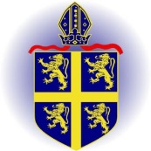

**Holy Trinity C of E Primary School**

**Curriculum Statement**

**Our School Vision**

*‘Love your neighbour as yourself.’*

*Matthew 22:36-40 “Teacher, which is the greatest commandment in the Law?” Jesus replied: “Love the Lord your God with all your heart and with all your soul and with all your mind. This is the first and greatest commandment. And the second is like it: Love your neighbour as yourself.”*

At Holy Trinity, positive, caring relationships are the foundation of our school community, woven through everything we do. In our school, everyone is valued and learns to value one another. Children, staff, and families are recognised and celebrated as unique individuals — each one loved, supported, and respected for who they are. Jesus’ teaching supports us to see the value in others, to be compassionate and to create an environment where everyone can flourish and achieve their full potential.

We recognise that our school community is part of a larger, diverse world, and we are committed to fostering an environment that is welcoming, inclusive, and accepting of all. At Holy Trinity, we nurture curious and motivated learners who take joy in discovery as they explore the world around them. We encourage our pupils develop into *responsible* global neighbours who *respect*, appreciate, and embrace the differences that make each of us unique.

We support our Holy Trinity family to flourish by nurturing their spiritual journey through:

**Looking in** with self-reflection,to love and value themselves as a unique child of God with self-respect and honesty.

**Looking out** with compassion and service to seek justice, peace, and care for all people and the planet we share.

**Looking up** with wonder and gratitude. We consider being a part of something greater than ourselves by taking time to pray, reflect, and be still.

**Our school values:**

***Respect* – The Parable of the Good Samaritan**

**Luke 10:25-37 teaches that compassion, and neighbourly love should be extended to everyone, irrespective of background or perceived differences.**

***Community* – The Parable of the Lost Sheep**

**Matthew 18: 10–14 teaches us the importance of community and belonging. God, like the shepherd, desires for all to be part of the flock, experiencing the joy of being connected and cared for.**

***Responsibility* – The Parable of Jesus feeding the 5000**

**John 6.1-13 teaches us that Jesus notices and cares about the everyday needs of all people.**

By fostering an inclusive community and working in partnership with Durham and Newcastle Diocesan Learning Trust and the Church of England, we are empowering our children to live full lives, reaching their potential and helping others to do the same. Through our spiritual development and our commitment to these Christian values, we encourage children to not only see the world through a broader lens but also actively contribute to making it a more inclusive and compassionate place. Our school is a place where *respect*, *community*, and *responsibility* guide our actions and help us live out the teaching to *love our neighbour as ourselves.*

Durham and Newcastle Diocesan Learning Trust’s vision**: "Every child matters**

**and no child is ever left behind..."**

The Church of England vision: **"Live life to its fullness."**

**Intent**

At Holy Trinity C of E Primary School, the curriculum is specifically tailored to meet the needs of all children in order to prepare them fully for the future lives they are going to lead. We believe that the curriculum we offer should fire children’s imaginations and be challenging yet enable all to experience success, regardless of their ability or interests. It should promote in children a self- belief and confidence which will enable them to reach their full potential.

***Powerful Knowledge:*** Our Curriculum ensures that every child has access to the best that has been said, thought and done through human history in every subject area which is illustrated on the long term plans for each curriculum area.

***Education with Character:*** Children are exposed to challenges which they will only succeed in through persistence and determination; they are encouraged to develop new talents and qualities unique to them and to express themselves clearly and articulately. They are exposed to situations where their thinking and opinions are challenged.

Our curriculum extends beyond the formal requirements of the National Curriculum as we recognise that this is only part of what children need. Of paramount importance within our curriculum are the values, skills and abilities we feel our children will require to take their place in the world; these will enable our children to be compassionate and driven leaders of our future.

Our curriculum is designed to provide a rich and varied programme of activities and learning experiences to meet the needs, interests and aspirations of all learners, within and beyond the school day.

We expect that all children will become creative, confident and respectful young adults who approach the next stage of their learning journeys with determination, enthusiasm and an ambitious outlook for their futures.

Active learning is encouraged though exploration, enquiry, investigation and structured play using first hand experiences wherever possible. We provide children with a range of opportunities to develop, use and refine key knowledge, understanding and skills and to practice and apply them regularly in different contexts.

We believe that it is important that children have a strong awareness of their local community and locality and of whom they are and where they fit in the world. We believe that successful learning depends on a positive partnership between home school and the wider community and we regularly raise money for local and national charities throughout the school year, as well as supporting our school Foodbank, which gives children a sense of responsibility and moral purpose.

**Implementation**

True learning is defined as changes in the long-term memory and creating mental models that allow children to apply learning in a specific context; all lessons at Holy Trinity C of E Primary School are crafted to follow the Rosenshine Ten Principals of Instruction framework:

**Planning for Progression**

All teaching and learning starts with assessment to ensure that work will be accessible, challenging and is providing the correct curriculum coverage that is needed to move children’s learning forward.

Lessons are broken down into specific discreet skills and knowledge that will enable children to achieve the desired outcome. Children should be clear on what they are learning and how to achieve this through clear learning intentions and success criteria. These are shared at the start of the lesson and referred to throughout.

When completing complex tasks, it is important that contextual knowledge has been taught to the children, and that they have access to it. The rationale behind this is that children focus on the skills they are practising, rather than having to process lots of different information at the same time.

**The Delivery of Learning:**

**Metacognitive Modelling and Direct Instruction**

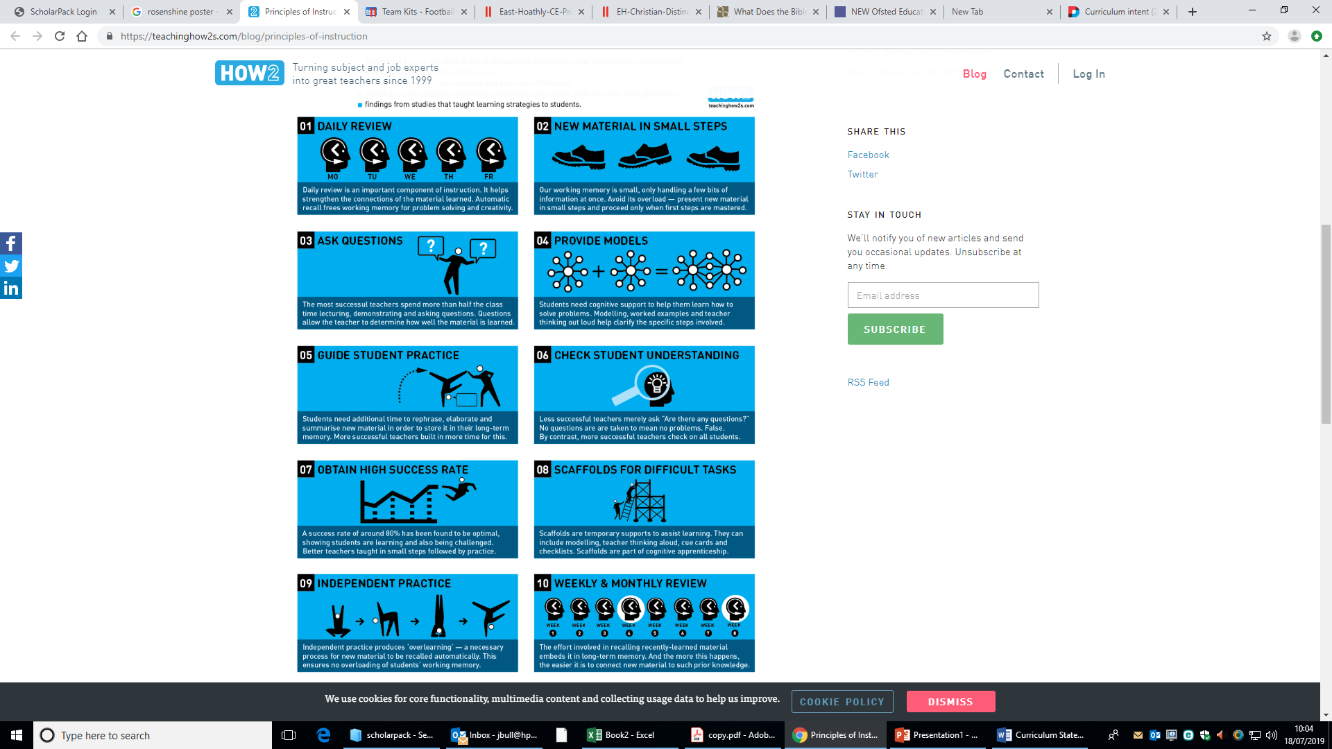Modelling is of a high standard with the teacher verbalising their thought process to the children, explaining how/why they are doing what they are doing. Direct modelling can take many forms, with teachers generally using the **part-whole** model where a concept is introduced in its general form, then divided up into distinguishable sub-parts, explicitly linked to the whole concept, or sequential ordering, where learning is presented in a sequential order as it would be in reality.

Direct instruction involves the repetition of key concepts / skills / summarising and practicing. Direct instruction will take the form of the modelling process and these elements will be the ‘teacher talk’ part of the lesson with the vast majority of the lesson being student practicing / applying skills/ This constitutes the ‘I’ part of the lesson in which delivery of concepts and skills is down to the teacher imparting knowledge.

**Contextual Vocabulary**



Much misunderstanding in learning comes from children’s inability to understand specific vocabulary in questions or from their misunderstanding of the contextual nature of a word. Vocabulary is specifically taught to enable children to access learning. Regular vocabulary building is an integral part of our curriculum.

**Questions for Learning**



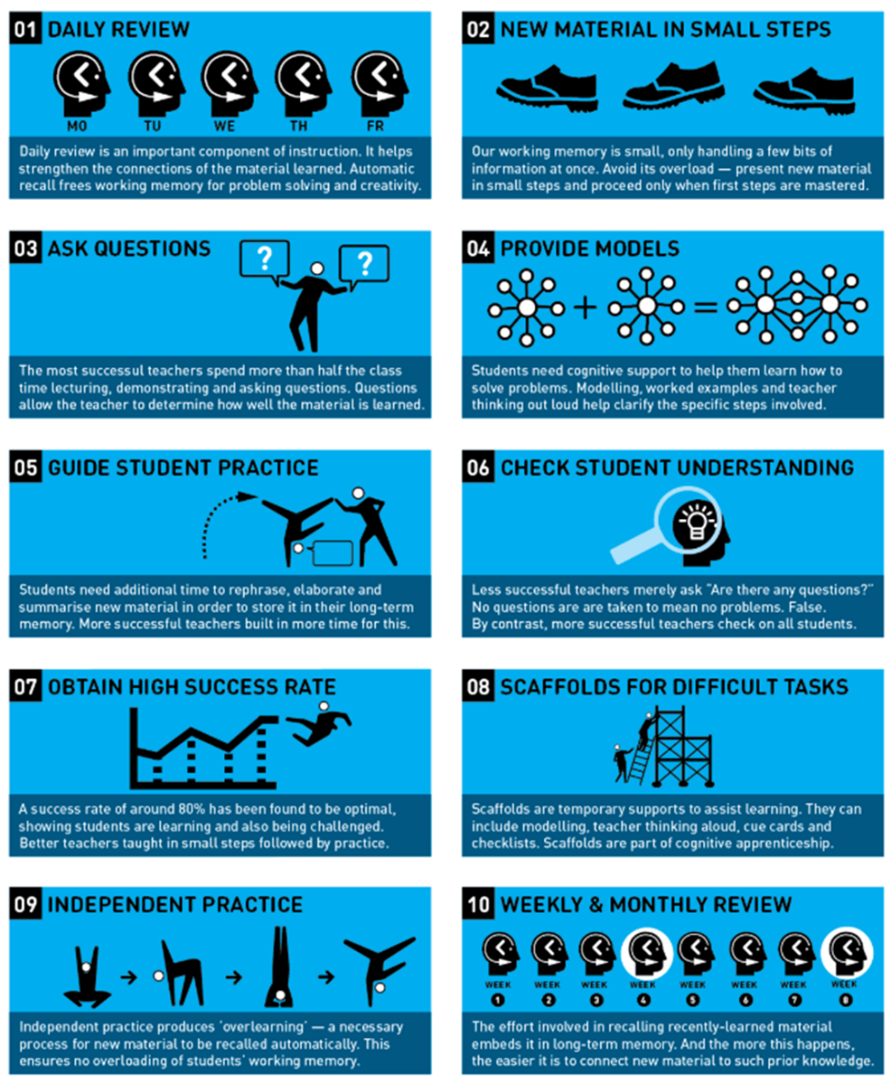Although questions can appear at many points within lessons, direct questioning should be used sparingly through Modelling / Direct Instructions to assess pupil’s ongoing understanding and used much more liberally after Modelling / Direct Instruction has been completed. Questioning during this period is to assess understanding, rather than assessment of learning to check whether the lesson can continue or any re-teaching needs to be done. A range of different question types are used at this point to both assess knowledge of the key concepts and then to extend thinking and analytical and evaluative questions.

**Independent Practice**

Children will have access to a range of different scaffolds such as the Success Criteria, clue cards, diagrams and checklist to support their **independent learning** at this time.

Once the child has demonstrated that they have fully understood the concept, more challenging problems be assigned in order to deepen and develop their understanding of the concept.

**Mini-Plenaries**



There are good opportunities within the teaching framework for assessment for learning, but an effective way to readdressing misconceptions that have arisen is to include mini-plenaries. These should be apparent throughout the lesson and be used at the teacher’s discretion, as and when appropriate. Lessons do not need a formal plenary.

**Cooperative Learning:**

We aim to ensure that children are given as many opportunities as possible to work collaboratively; allowing them the chance to work with a range of different learners throughout their journey. Children then have a greater understanding of what it takes to complete a task, develop independence and leadership skills and work towards achieving common goals. Working collaboratively also offers learners the opportunity to support, coach and discuss learning prior to the completion of tasks and encourages children to take risks within a safe environment.

Cooperative learning is built on the foundations that we should build connections with each other, as we learn best when we are safe, therefore cooperative learning involves team building and class building activities where children learn about their own similarities and differences in a fun, non-threatening way. Working in this way allows learning to be active but it also ensures that children develop an awareness of the needs of others, leading to the development of tolerance and social justice.

**Extra-Curricular Activities:**

Holy Trinity C of E Primary School has a wide variety of extra-curricular activities involving children from across school. School makes a conscious effort to monitor attendance in these activities in order to ensure that children develop drive and persistence.

***Examples of some of the clubs on offer:***

|  |  |  |  |  |
| --- | --- | --- | --- | --- |
| Football | Netball | Football | Social Club KS1 | Social Club KS2 |
| Choir | Cookery Club | Games Club | Sports Leaders | Digital Leaders |
| Worship Group | Reading | Eco Warriors | Change 4 Life | Well-Being Ambassadors |

**Community:**

As a founding member of the DDMAT, now known as DNDLT Holy Trinity C of E Primary School works alongside many schools and communities; we support a range of local, national and global charities and have developed a strong, working relationship with Holy Trinity Church. Within the MAT community, we support and aid development across a range of strategies and have ensured that we share curriculum knowledge and intent by deploying our staff where possible. School Council play a big role in the running of the school and the development of pupil voice has had a major impact on the school community.

**Impact:**

Our curriculum is carefully planned for progression; it is designed to be challenging and relevant to our pupils and their local identity and builds upon their prior knowledge and understanding. Our curriculum gives all children opportunities and experiences needed to go forward to be successful in their education and future lives, enabling them to achieve and fulfil their dreams and all of their aspirations.

If children are keeping up with the curriculum, they are deemed to be making the expected amount of progress we expect and are therefore working at the expected standard for their year group.

We instil a belief in all of our children that they should dream big, aim as high as the stars and that with hard work, strength of character and single-minded determination, they will achieve all of their dreams.

Date of Review: September 2025

Date of next Review: September 2026