

Holy Trinity Church of England Primary School
Worship Policy and Vision Statement

Our long-standing mission is to provide ‘Excellent education in a Christian Environment’.

At Holy Trinity, positive, caring relationships are the foundation of our school community, woven through everything we do. In our school, everyone is valued and learns to value one another. Children, staff, and families are recognised and celebrated as unique individuals — each one loved, supported, and respected for who they are. Jesus’ teaching supports us to see the value in others, to be compassionate and to create an environment where everyone can flourish and achieve their full potential.

We recognise that our school community is part of a larger, diverse world, and we are committed to fostering an environment that is welcoming, inclusive, and accepting of all. At Holy Trinity, we nurture curious and motivated learners who take joy in discovery as they explore the world around them. We encourage our pupils develop into responsible global neighbours who respect, appreciate, and embrace the differences that make each of us unique.
We support our Holy Trinity family to flourish by nurturing their spiritual journey through:

Looking in with self-reflection, to love and value themselves as a unique child of God with self-respect and honesty.
Looking out with compassion and service to seek justice, peace, and care for all people and the planet we share.
Looking up with wonder and gratitude. We consider being a part of something greater than ourselves by taking time to pray, reflect, and be still.

Aims
As a Church of England Voluntary Aided School our aim is for every child to reach his or her own God-given potential, which potential we believe has been given in order that he/she can contribute full-heartedly and creatively towards a just and caring society. To this end we aim to enable each child to acquire a reasoned set of attitudes and Christian values, namely respect, community and responsibility.

We aim to provide a broad, balanced, well- planned curriculum that is intellectually stimulating, challenging and enjoyable, giving the children opportunities to reach the highest standards of academic, aesthetic, creative and sporting achievement.
We aim to develop lively and enquiring minds, encouraging the children to acquire knowledge, skills, and practical abilities as well as a sense of purpose and enjoyment in using them.
We aim to stimulate and develop the children’s use of language and number to enable them to be able to communicate effectively and to enjoy adult life and the world of work.
We aim to develop in the children qualities of mind, body, spirit, feeling, imagination, artistic impression and aesthetic sensitivity.
We aim to enable the children to achieve good health and physical development through physical education.
We aim to develop the children’s social skills to enable them to work collaboratively, enjoying confident personal and work relationships.
We aim to maintain high standards of behaviour, dress, courtesy and self-control.
We aim to help children develop a positive self-image and the confidence to manage opportunities to develop their own talents and personalities to live as independent, self-motivated members of our School family.
We aim to encourage a sense of pride and ownership in Holy Trinity Church of England Primary School.

Rationale
The Trust Deed and school vision statement inform the policy and practice of collective worship in Holy Trinity C of E School. School worship is an affirmation and celebration of the Christian foundation, values and ethos of the school.
Worship is central to the life and purposes of our school and will reflect the Christian understanding of God as Trinity. This will include belief in God the source of all being and life, belief in Jesus who reveals God’s love by his life, death and resurrection and belief in the Holy Spirit who makes the presence of Jesus known in the world.

Aims
Through Worship, we aim to:
• enable children and staff to explore and celebrate the differences and diversity found in the variety of forms of worship in the Anglican Christian tradition;
• lead the school community to the ‘threshold of worship’ in order for them to make an informed choice about their own involvement and to consider their own personal relationship with Jesus Christ;
• seek to deepen and widen the experience of those of ‘faith’ and encourage those of ‘no faith’ so that they begin to feel for themselves something of what it means to worship;
• use celebration, silence, stilling, reflection, contemplation, meditation, prayer, song, symbols and imagery as vehicles for worship and spiritual growth;
• provide opportunities for the whole school community to address God directly through Jesus in the power of the Holy Spirit through acknowledging his presence, reflecting upon his character and giving Him praise and honour;
• use a vocabulary of worship that encourages the whole school community to attend, participate and lead worship;
• encourage all present to explore their own beliefs and understanding of God within a Christian framework by learning more about the Christian faith and by encountering Christ through worship;
• raise awareness through reflection of the ultimate questions of life relating to matters of faith;
• reaffirm, strengthen and practice key Christian values. (e.g. love, peace, compassion, forgiveness, self-giving) and celebrate each unique individual member of the school community as made in the image of God;
• nurture and encourage respect and care for God's created world by promoting a positive attitude to environmental issues locally, nationally and globally;
• seek to provide opportunities for spiritual, social and moral development that is characterised be feelings such as awe, wonder, being uplifted, elation, appreciation, gratitude, respect, and reverence;
• develop a sense of community within the school, the locality, (e.g. local church) and foster the sense of being part of a wider community though the celebration of achievements, festivals and special occasions;
• foster a concern for the needs of others.

Legal Framework
There must be a daily act of collective worship for all pupils which takes account of their age and aptitude. (Education Reform Act 1988). Parents have the right to withdraw children from collective worship and suitable arrangements should be made to accommodate these children. Since this is a church school however, worship is central to its life and work and is regarded as a very important part of our children’s education.

Organisation
All children attend a daily collective act of worship.
A typical week is as follows: -

Day and time | Monday  2:40pm – 3pm | Tuesday  2:40pm – 3pm | Wednesday  Church week:  9am – 9:45am | Wednesday  No Church week:  2:40pm – 3pm | Thursday  2:40pm – 3pm | Friday  2:30pm – 3pm
Worship leader | Teacher (see rota) | Headteacher (AB) | Church | Worship group to lead in the hall with support from RE Lead (NW) | SLT (KR) | Headteacher (AB)
Focus | Roots and Fruits Theme | Roots and Fruits Theme reflection and Songs of Praise | Roots and Fruits Theme continued | Roots and Fruits Theme continued | Justice theme (Global Neighbours/Picture News/National events) | Celebration Worship linking with school vision and values

Reflection

Children will then be given the opportunity to reflect upon Monday’s worship and respond to the questions asked during it. Children will reflect by ‘looking in’ ‘looking out’ and ‘looking up’ using their own classroom reflective spaces to do this.

Day and time | Tuesday 2:30pm – 2:40pm | Thursday 2:30pm – 2:40pm
Task | Begin task given in Monday’s worship. Allow the children to reflect and develop their spirituality by looking In, Out and Up. | Complete task given in Monday’s worship. Allow the children to reflect and develop their spirituality by looking In, Out and Up.  Rec – Y4 to add reflections to reflection display in classroom and class worship book.  Y5 and 6 to add reflections to their own reflection books.

Staff Attending Worship
We believe that it is important for pupils to see the value we attach as a school to worship. One way we hope to achieve this is by staff attending acts of worship alongside the children. All staff members attend worship throughout the week and lead sessions regularly. No intervention work should take place during worship time.

Withdrawal
Parents have the right to withdraw pupils from worship. Prospective parents are informed of the importance we attach as a School to worship and Christian belief. We aim to ensure that the values underpinning the education in the School are Christian values. A parent wishing to withdraw a child from the Daily Act of Collective Worship (Education Act 1988) must make a written request to the Headteacher.
(Occasionally small groups of children may not attend whole school worship, but if this is the case the teacher, teaching assistant in charge will involve the pupils in a short act of worship, prayer and reflection.)

Planning, Record Keeping, Monitoring and Evaluation
The Worship Coordinator has overall responsibility for drawing up a timetable of worship for each term and a rota of worship leaders. Each academic year a plan is created which indicates termly and weekly themes following the ‘Roots and Fruits’ book.

The Worship Coordinator will carry out the following monitoring throughout the year:
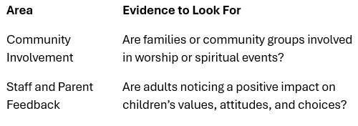
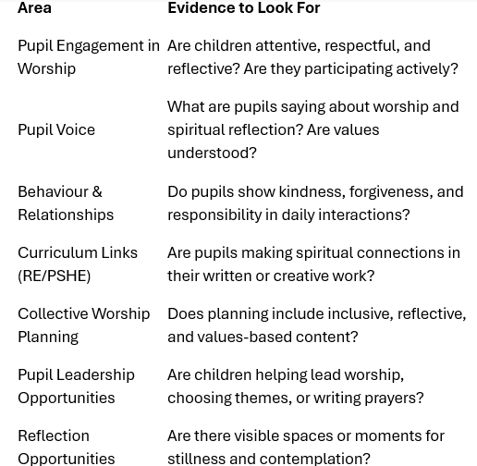

Updated: July 2025
Completed by: Mrs N Wager

